# Generated QA Summary

--- Entry for custom_id: d5c4b87e0dba11ecb1e81171463288e9 ---

Image Source 1 -



Caption for image source 1: Frangipani flowers Frangipani (Plumeria) flowers in Perth, Western Australia.

Example Question - "What color is the center part of a Frangipani flower?"

Example Answer - "The center part of a Frangipani flower is yellow."

Additional Text Source 1 - The word comes ultimately from Italian, named after Marquis Muzio Frangipani. The word first denoted the frangipani plant, from which was produced the perfume originally said to flavor frangipane. (from: Frangipane)

Generated Question - Is the name of the Frangipani flower related to a perfume originally flavored by the plant?

Generated Answer - Yes, the name Frangipani comes from a perfume originally flavored by the plant.

--- Entry for custom_id: d5bf37a00dba11ecb1e81171463288e9 ---

Image Source 1 -

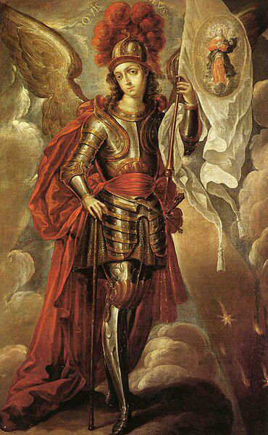

Caption for image source 1: San Miguel Arcángel - Cristóbal de Villalpando Saint Michael the Archangel.

Image Source 2 -

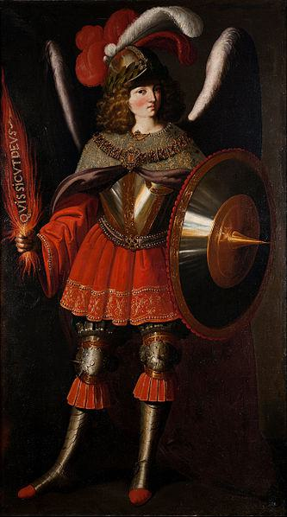

Caption for image source 2: Francisco de Zurbarán and Studio - The Archangel Michael - Google Art Project.

Example Question - "Saint Michael the Archangel's helmet had longer plumage on which painting: The Archangel Michael or Saint Michael the Archangel?"

Example Answer - "The Archangel Michael had longer plumage."

Additional Text Source 1 - The Prayer to Saint Michael the Archangel usually refers to one specific Catholic prayer to Michael the Archangel, among the various prayers in existence that are addressed to him. It falls within the realm of prayers on spiritual warfare. (from: Prayer to Saint Michael)

Generated Question - Which painting shows Saint Michael the Archangel holding a shield, and how does this relate to the theme of spiritual warfare in the prayer?

Generated Answer - The Archangel Michael painting shows him holding a shield, symbolizing protection in spiritual warfare.

--- Entry for custom_id: d5cc89be0dba11ecb1e81171463288e9 ---

Image Source 1 -

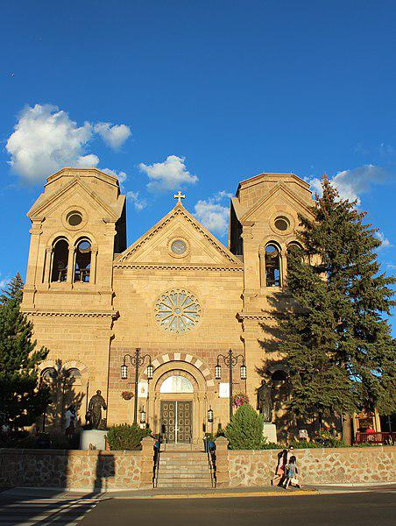

Caption for image source 1: Santa Fe, New Mexico, USA - Cathedral Basilica of St. Francis of Assisi - panoramio.

Image Source 2 -

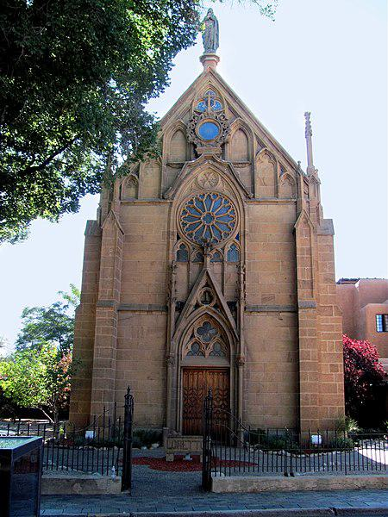

Caption for image source 2: Santa Fe, New Mexico, USA - Loretto Chapel - panoramio (1).

Example Question - "When it comes to the form of window on their facades, what do the Loretto Chapel and the Cathedral Basilica of St. Francis of Assisi have in common?"

Example Answer - "When it comes to the form of window on their facades, the Loretto Chapel and the Cathedral Basilica of St. Francis of Assisi have rose windows in common."

Additional Text Source 1 - While the mother church, the Cathedral Basilica of Saint Francis of Assisi, is in the city of Santa Fe, its administrative center is in the city of Albuquerque. (from: Roman Catholic Archdiocese of Santa Fe)

Generated Question - Are both the Cathedral Basilica of St. Francis of Assisi and the Loretto Chapel located in the same city, and where is the administrative center of their archdiocese?

Generated Answer - Yes, both are in Santa Fe, but the archdiocese's administrative center is in Albuquerque.

--- Entry for custom_id: d5cb1d860dba11ecb1e81171463288e9 ---

Image Source 1 -

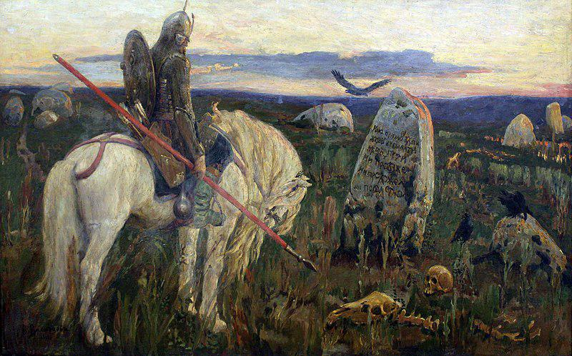

Caption for image source 1: 1919 Vasnetsov Ritter an der Kreuzung anagoria Viktor Mikhailovich Vasnetsov A knight at the crossroads.

Example Question - "What kind of weapon does the horse rider have in his hand in A Knight at the Crossroads?"

Example Answer - "The horse rider has a spear in his hand."

Additional Text Source 1 - Some argue that nature represents a chaotic, lawless order which is in direct confrontation with the civilisation of Camelot throughout Sir Gawain and the Green Knight. The green horse and rider that first invade Arthur's peaceful halls are iconic representations of nature's disturbance. (from: Sir Gawain and the Green Knight)

Generated Question - How does the knight on the white horse in Vasnetsov's painting contrast with the green horse and rider symbolizing nature's chaos in Sir Gawain and the Green Knight?

Generated Answer - The knight on the white horse represents order and civilization, contrasting nature's chaotic green horse and rider.

--- Entry for custom_id: d5ca078e0dba11ecb1e81171463288e9 ---

Image Source 1 -



Caption for image source 1: Spaltblättlinge.

Example Question - "Is the Spaltblättlinge shaped as a shell?"

Example Answer - "Yes, the Spaltblättlinge is shell-shaped."

Additional Text Source 1 - Some argue that nature represents a chaotic, lawless order which is in direct confrontation with the civilisation of Camelot throughout Sir Gawain and the Green Knight. The green horse and rider that first invade Arthur's peaceful halls are iconic representations of nature's disturbance. (from: Sir Gawain and the Green Knight)

Generated Question - Could the shell-shaped Spaltblättlinge symbolize nature's chaotic order disrupting civilization like the green horse in Sir Gawain and the Green Knight?

Generated Answer - Yes, the Spaltblättlinge's natural form can symbolize nature's chaotic disruption of civilization.

--- Entry for custom_id: d5c605800dba11ecb1e81171463288e9 ---

Image Source 1 -

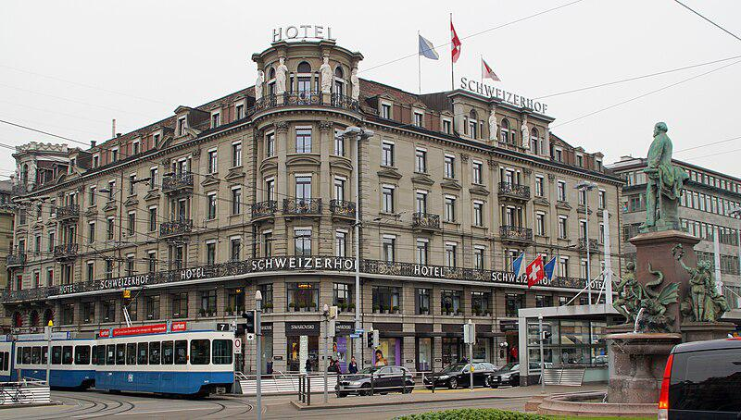

Caption for image source 1: 2015-03-25 Bahnhofplatz7 This photo was taken by Robert Kropf (User:TheRunnerUp) and released under the license CC BY-SA 4.0..

Example Question - "How many statues are on the Schweizerhof Hotel in Bahnhofplatz?"

Example Answer - "There are 6 statues on the roof of the Schweizerhof Hotel in Bahnhofplatz."

Additional Text Source 1 - Some of the city's most recognisable buildings are hotels from this period, such as the Schweizerhof Hotel (1845), Grand Hotel National (1870), and Château Gütsch (1879). (from: Lucerne)

Generated Question - Are the Schweizerhof Hotel and Château Gütsch from the same century based on their construction years?

Generated Answer - Yes, both were built in the 19th century.

--- Entry for custom_id: d5c44d440dba11ecb1e81171463288e9 ---

Image Source 1 -

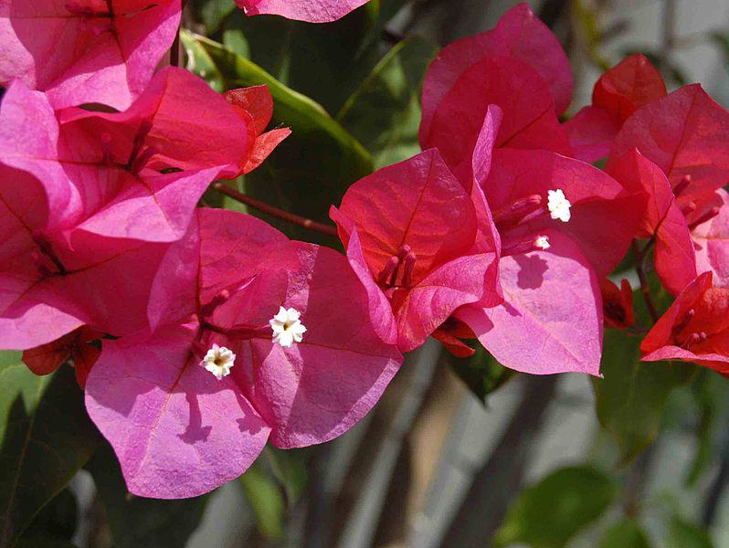

Caption for image source 1: Nyctaginaceae - Bougainvillea buttiana Flower surrended by bracts of Bougainvillea buttiana.

Image Source 2 -

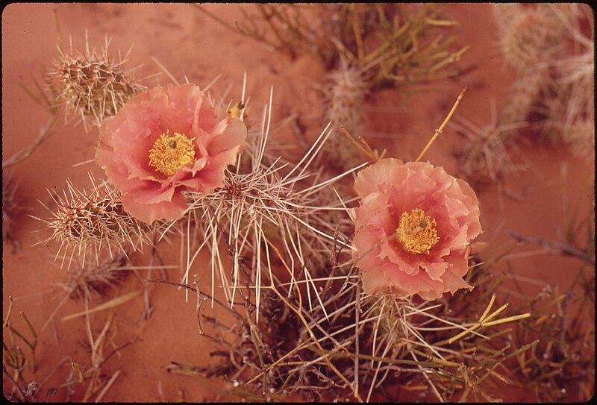

Caption for image source 2: ORANGE MALLOW, SHOWY DESERT FLOWER - NARA - 544877.

Example Question - "Is the Orange Globe Mallow and the Nyctaginaceae filamnet both pink?"

Example Answer - "No, the Orange Globe Mallow and the Nyctaginaceae filamnet are not both pink."

Additional Text Source 1 - Some of the city's most recognisable buildings are hotels from this period, such as the Schweizerhof Hotel (1845), Grand Hotel National (1870), and Château Gütsch (1879). (from: Lucerne)

Generated Question - Are the flowers in the images similar in color to the historic hotels mentioned in Lucerne?

Generated Answer - No, the flowers are pink and orange, unlike the hotels which are not described by color.

--- Entry for custom_id: d5da60840dba11ecb1e81171463288e9 ---

Example Question - What elements are used to create the explosive forces used by the technology that's currently being explored as a higher velocity alternative to conventional artillery?

Example Answer - Hydrogen and oxygen.

Image Source 1 -

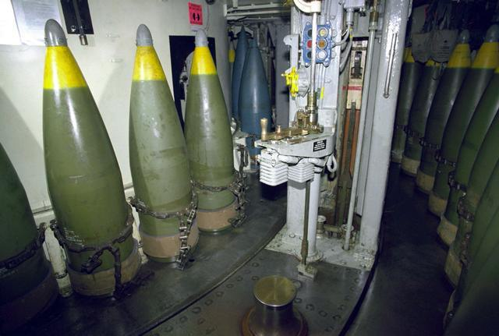

Generated Question - How does the propellant used in combustion light-gas guns differ from the propellant in the 16" artillery shells shown in the image?

Generated Answer - Combustion light-gas guns use hydrogen and oxygen gases, while 16" artillery shells use solid nitrocellulose-based propellants.

--- Entry for custom_id: d5c385620dba11ecb1e81171463288e9 ---

Image Source 1 -

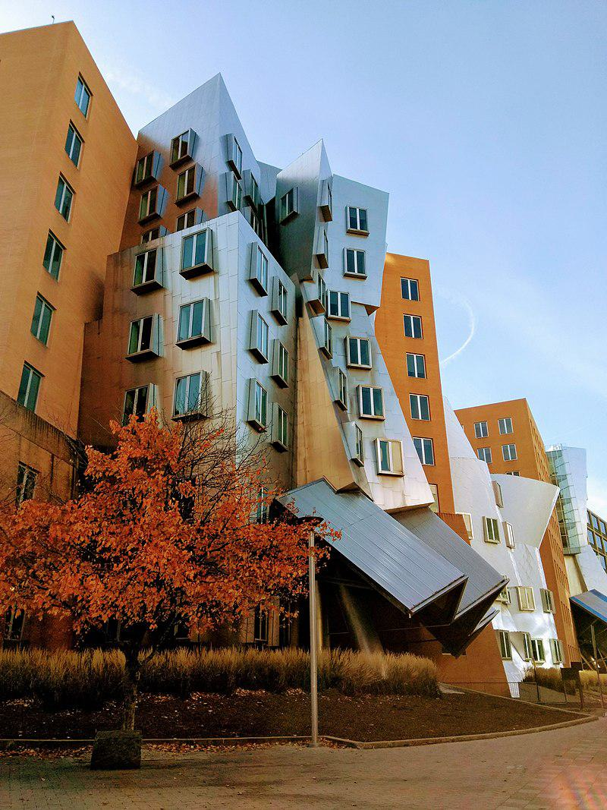

Caption for image source 1: Stata Center -MIT photo by Linda Fletcher.

Image Source 2 -

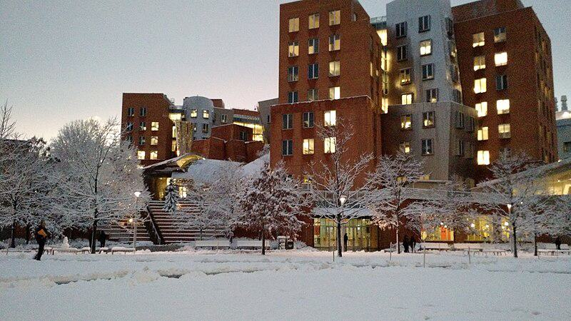

Caption for image source 2: Stata Center snow 2016 The Stata Center on the MIT Campus in snow, February 2016.

Example Question - "Are the buildings of the Stata Center uniform height?"

Example Answer - "The buildings of the Stata Center are not of uniform height."

Additional Text Source 1 - The wall and trees provide a uniform background for the chapel, and isolate the site from the noise and bustle of adjacent buildings. (from: MIT Chapel)

Generated Question - Considering the Stata Center's varying building heights and the uniform background of the MIT Chapel, how do their surroundings differ in visual impact?

Generated Answer - The Stata Center has varied heights creating dynamic visuals, while the MIT Chapel's uniform background isolates it visually.

--- Entry for custom_id: d5dd1d740dba11ecb1e81171463288e9 ---

Example Question - Which person gave the island into which Somes Sound runs its name?

Example Answer - Samuel de Champlain gave Mount Desert Island, the island into which Somes Sound runs, its name.

Image Source 1 -

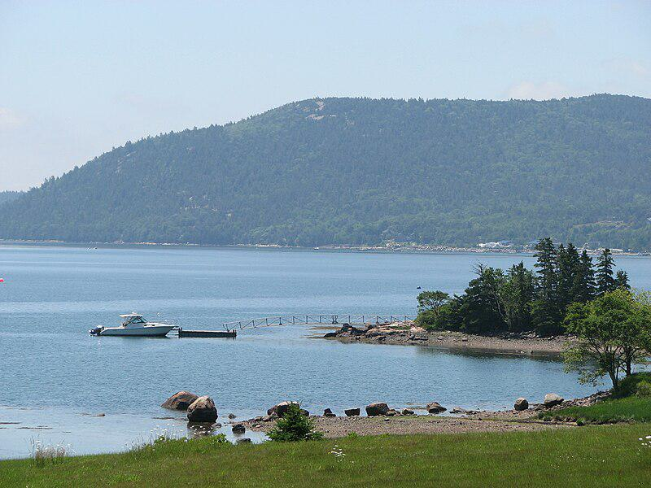

Generated Question - What type of water body is Somes Sound on Mount Desert Island, and how deep can it get?

Generated Answer - Somes Sound is a fjard on Mount Desert Island, with depths up to approximately 175 feet.

--- Entry for custom_id: d5d434e80dba11ecb1e81171463288e9 ---

Example Question - Historically, members of the Imperial army of the country that would refer to a "collar patch" as a Kragenpatte or Kragenspiegel would wear what color?

Example Answer - Prussian Blue

Image Source 1 -

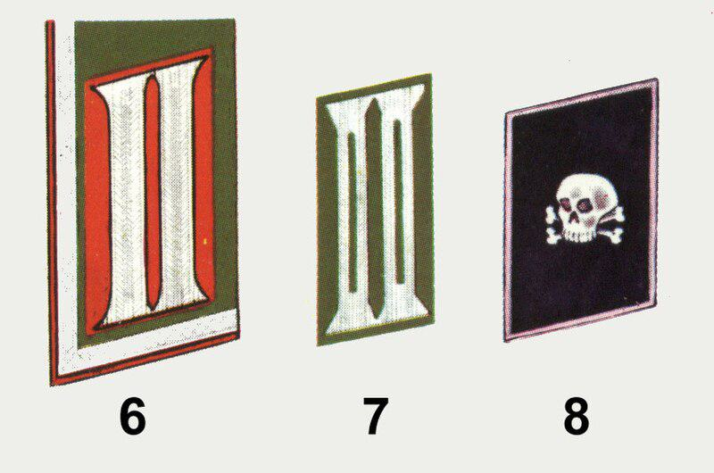

Generated Question - Which Heer collar patch shown is associated with an NCO rank symbolized by a braid encircling the collar?

Generated Answer - Collar patch 6, Artillery NCO (dress), is associated with the NCO braid symbol.

--- Entry for custom_id: d5bfd3400dba11ecb1e81171463288e9 ---

Image Source 1 -

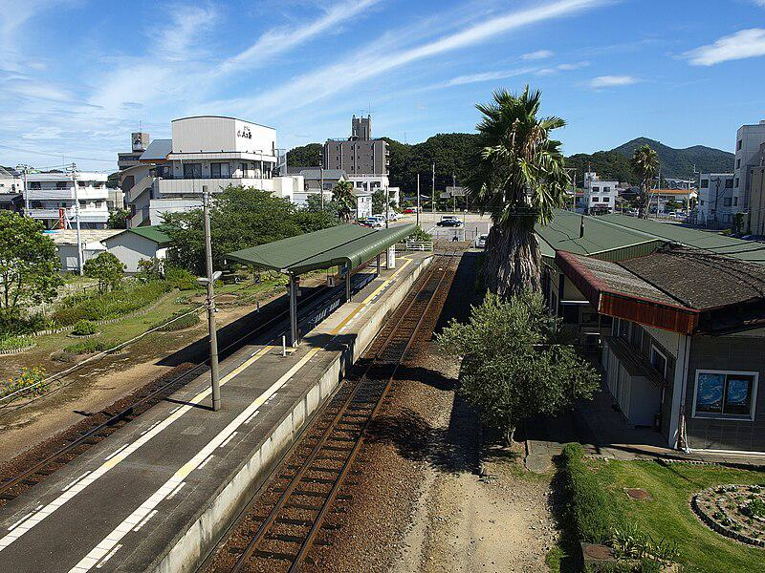

Caption for image source 1: Naruto railway station (overview) Naruto railway station overview ,Tokushima, Japan..

Example Question - "How many railway tracks appear at the Naruto railway station in Tokushima, Japan?"

Example Answer - "There are two railway tracks at the Naruto Railway Station in Tokushima, Japan."

Additional Text Source 1 - Konpiramae Station (金比羅前駅, Konpiramae-eki) is a railway station on the Naruto Line in Naruto, Tokushima Prefecture, Japan. It is operated by JR Shikoku and has the station number "N06". (from: Konpiramae Station)

Generated Question - Are the Naruto railway station and Konpiramae Station both located in the same city and served by the Naruto Line?

Generated Answer - Yes, both stations are in Naruto city and served by the Naruto Line.

--- Entry for custom_id: d5bfa64a0dba11ecb1e81171463288e9 ---

Image Source 1 -

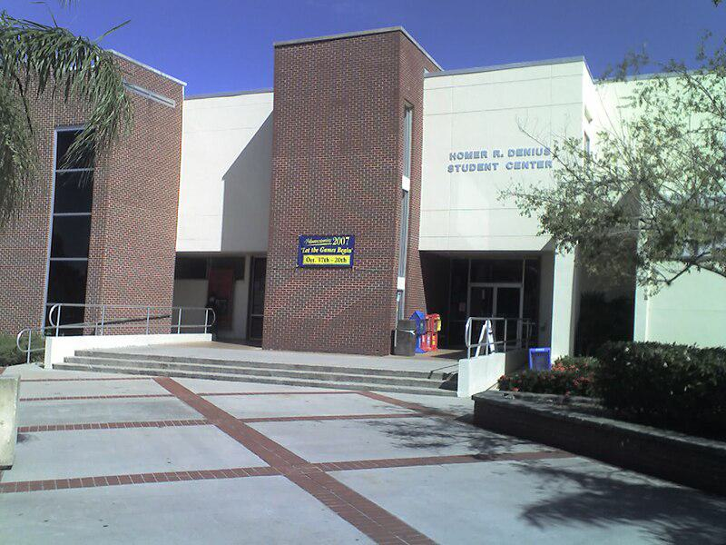

Caption for image source 1: FlTechSUB Florida Institute of Technology's Homer Denius Student Union Building, home to the campus bookstore, university mail annex, SUB Cafe, Office of Student Life, the John and Martha Hartley Room, as well as several student organizational offices..

Example Question - "Are there railings at the Florida Institute of Technology's Homer Denius Student Union Building?"

Example Answer - "Yes, there are railings."

Additional Text Source 1 - Florida Institute of Technology has 132 active student organizations on campus. The university-sponsored student organizations, such as Student Government Association, Campus Activities Board, the Homecoming Committee, FITV (CCTV Channel 99 on campus), and The Crimson (student-run university newspaper) operate in primary university funding. (from: Florida Institute of Technology)

Generated Question - Does the Florida Institute of Technology's Homer Denius Student Union Building likely support activities for its 132 active student organizations?

Generated Answer - Yes, it houses offices and spaces for student organizations and activities.

--- Entry for custom_id: d5c3e5160dba11ecb1e81171463288e9 ---

Image Source 1 -



Caption for image source 1: The Rat (Graffiti in London) Banksy rat graffiti on City Road, London, United Kingdom..

Image Source 2 -



Caption for image source 2: Graffiti 47 on legal wall of PBS (2009) in Třebíč, Třebíč District Graffiti on legal wall of PBS factory in Trebic-Jejkov, Czech Republic..

Example Question - "What colors were used in the cartoon character in the Graffiti on legal wall of PBS factory that were not used in Banksy rat graffiti on City Road in London?"

Example Answer - "Red, blue, and yellow were used in the graffiti at the legal wall of PBS."

Additional Text Source 1 - According to Hattenstone, "anonymity is vital to him because graffiti is illegal". Banksy reportedly lived in Easton, Bristol during the late 1990s, before moving to London around 2000. (from: Banksy)

Generated Question - How does Banksy's need for anonymity relate to the legal status of the graffiti on the PBS factory wall?

Generated Answer - Banksy's anonymity is crucial because his graffiti is illegal, unlike the legal graffiti on the PBS factory wall.

--- Entry for custom_id: d5c9d2460dba11ecb1e81171463288e9 ---

Image Source 1 -

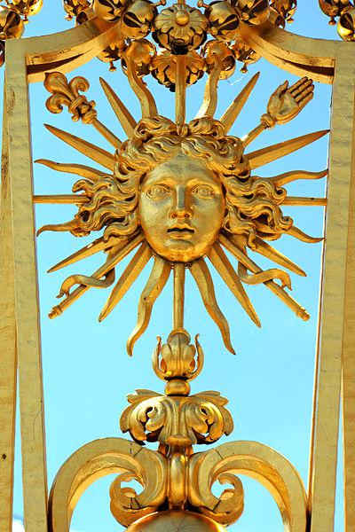

Caption for image source 1: Palace of Versailles - Louis XIV, 22 June 2014.

Example Question - "What human body part can be found on one of the spikes around the head on the Grille royale of Versailles, France?"

Example Answer - "A hand can be found on one of the spikes around the head on the Grille Royale of Versailles, France."

Additional Text Source 1 - In 2003, a new restoration initiative – the "Grand Versailles" project – was started, which began with the replanting of the gardens, which had lost over 10,000 trees during Hurricane Lothar on 26 December 1999. One part of the initiative, the restoration of the Hall of Mirrors, was completed in 2006. (from: Palace of Versailles)

Generated Question - How does the restoration of the Palace of Versailles relate to the preservation of the Grille Royale's intricate golden design?

Generated Answer - The restoration helps preserve the Grille Royale's intricate golden design by maintaining the palace's overall historic and artistic integrity.

--- Entry for custom_id: d5ca8bfa0dba11ecb1e81171463288e9 ---

Image Source 1 -



Caption for image source 1: Marissa Castelli Simon Shnapir 2013 U.S. Figure Skating Pairs Champions Marissa Castelli and Simon Shnapir stand atop the podium after becoming the 2013 U.S. Figure Skating Pairs Champions.

Example Question - "What color did Marissa Castelli wear after becoming the 2013 U.S. Figure Skating Pairs Champion?"

Example Answer - "Marissa Castelli wore the color red after becoming the 2013 U.S. Figure Skating Pairs Champion."

Additional Text Source 1 - Tran and Castelli placed sixth at the 2018 U.S. Figure Skating Championships. They ended their partnership soon after and Tran went to California to try out with other partners. (from: Mervin Tran)

Generated Question - Did Marissa Castelli win the 2013 U.S. Figure Skating Pairs Championship before or after placing sixth with Tran in 2018?

Generated Answer - Marissa Castelli won the 2013 championship before placing sixth with Tran in 2018.

--- Entry for custom_id: d5d868b00dba11ecb1e81171463288e9 ---

Example Question - The public use Falcon Field and the state-owned facility located west of Adak in Alaska are both types of what?

Example Answer - Airports.

Image Source 1 -

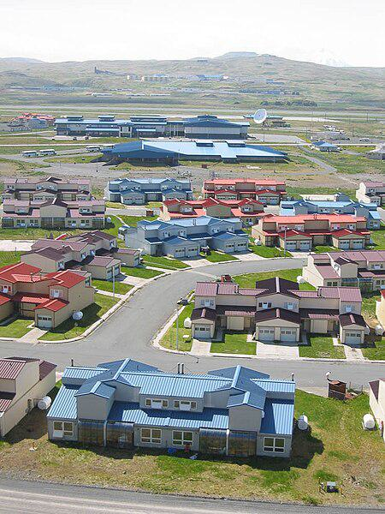

Generated Question - Are both the Atlanta Regional Airport and the airport near the residential area in Adak, Alaska public use airports?

Generated Answer - Yes, both are public use airports.

--- Entry for custom_id: d5ddccba0dba11ecb1e81171463288e9 ---

Example Question - What type of armor and weapons would Spartacus have likely worn as a gladiator?

Example Answer - He would have probably worn a small rectangular, square or circular shield and a very short sword with a slightly curved blade.

Image Source 1 -

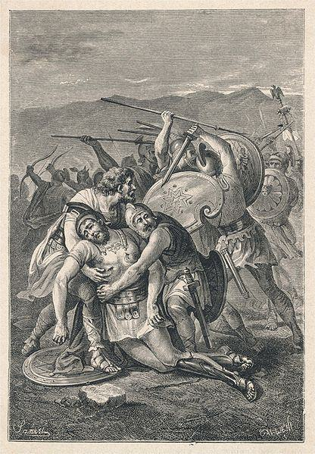

Generated Question - Considering Spartacus was a Thracian gladiator, what type of shield and sword would he likely have used in battle as shown in the image?

Generated Answer - He would likely have used a small rectangular, square, or circular shield and a short curved sword called a sica.

--- Entry for custom_id: d5bf5dd40dba11ecb1e81171463288e9 ---

Image Source 1 -

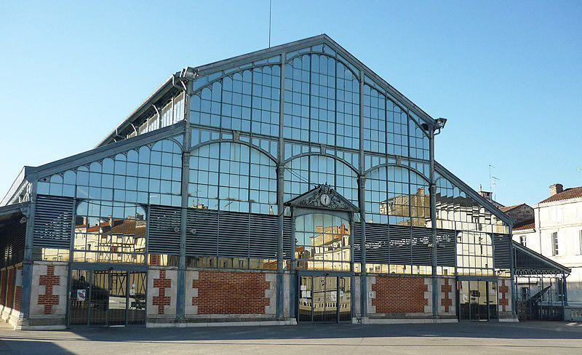

Caption for image source 1: Halles de Niort.

Example Question - "How many people are around the clock in the sculpture over the door of the Halles de Niort?"

Example Answer - "There are 4 people around the clock."

Additional Text Source 1 - There are no airports with scheduled airline service within the département, although Niort-Souche Airport is used for private movements. The nearest commercial airports are at Poitiers (Poitiers - Biard Airport), La Rochelle (La Rochelle - Île de Ré Airport) and Nantes (Nantes Atlantique Airport). (from: Deux-Sèvres)

Generated Question - Considering the Halles de Niort's location in Deux-Sèvres, which nearby commercial airports serve this area?

Generated Answer - The nearby commercial airports are Poitiers - Biard, La Rochelle - Île de Ré, and Nantes Atlantique.

--- Entry for custom_id: d5db3c160dba11ecb1e81171463288e9 ---

Example Question - In Arthurian legend, the father of Lancelot and Hector de Maris takes which king's sister-in-law to be his wife?

Example Answer - Ban marries the sister to King Bors's wife.

Image Source 1 -

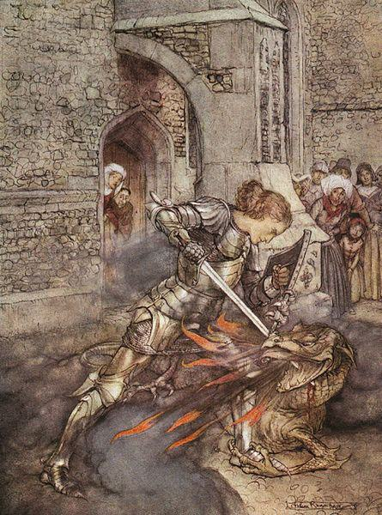

Generated Question - How is Lancelot, son of Ban, depicted in the image in relation to his legendary family background?

Generated Answer - Lancelot, Ban's son, is shown heroically slaying a dragon, reflecting his noble Arthurian heritage.

--- Entry for custom_id: d5da5b7a0dba11ecb1e81171463288e9 ---

Example Question - How big is the diameter of the smooth cap in the mycorrhizal organism that lives in symbiosis with the trees?

Example Answer - About 4–10 cm.

Image Source 1 -



Generated Question - How does the cap color and ring coloration of the mycorrhizal mushroom under coniferous trees differ from the Death Cap shown in the image?

Generated Answer - The mycorrhizal mushroom has a brown cap with purplish or greyish hue and a grey/violet ring, unlike the Death Cap.

--- Entry for custom_id: d5d416340dba11ecb1e81171463288e9 ---

Example Question - Did Ron McLarty or Peter Thomas live to a longer age?

Example Answer - Peter Thomas lived to a longer age.

Image Source 1 -



Generated Question - Did Peter Thomas have a longer career in narration than Ron McLarty had in audiobook narration?

Generated Answer - Yes, Peter Thomas had a longer narration career spanning over 70 years.

--- Entry for custom_id: d5c9e6f00dba11ecb1e81171463288e9 ---

Image Source 1 -

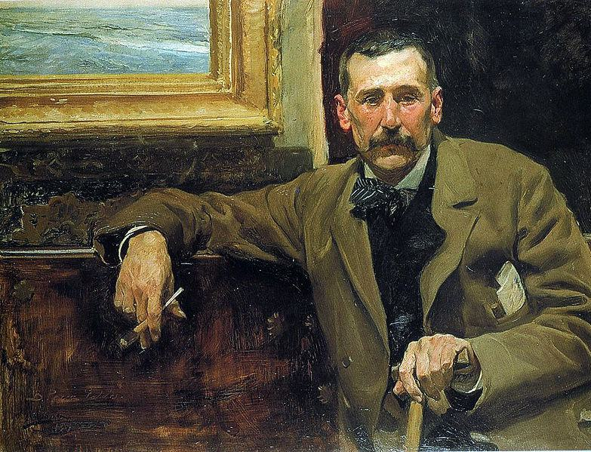

Caption for image source 1: Perez galdos.

Image Source 2 -

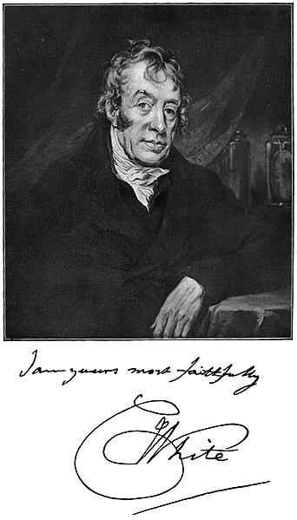

Caption for image source 2: White Charles physician Picture of Charles White, the physician.

Example Question - "Are the men in Joaquín Sorolla's "Portrait of Benito Pérez Galdós" and photograph of "Picture of Charles White, the physician" (taken in 1904) sitting down?"

Example Answer - "The men in Joaquín Sorolla's "Portrait of Benito Pérez Galdós" and photograph of "Picture of Charles White, the physician" (taken in 1904) are sitting down."

Additional Text Source 1 - Portrait of Benito Pérez Galdós (Spanish: Retrato de Benito Pérez Galdós is an oil portrait painting by Joaquín Sorolla in 1894. It represents the Spanish writer Benito Pérez Galdós at aged 51.In 1973 it was acquired by the grandsons of Galdós for the Cabildo Insular de Gran Canaria. (from: Portrait of Benito Pérez Galdós)

Generated Question - Are both Benito Pérez Galdós and Charles White depicted as seated men in their respective portraits?

Generated Answer - Yes, both Benito Pérez Galdós and Charles White are shown sitting down in their portraits.

--- Entry for custom_id: d5d589ba0dba11ecb1e81171463288e9 ---

Example Question - Who were the parents of the god in Norse mythology projected as the husband of the goddes Frigg?

Example Answer - Odin is the son of Bestla and Borr

Image Source 1 -

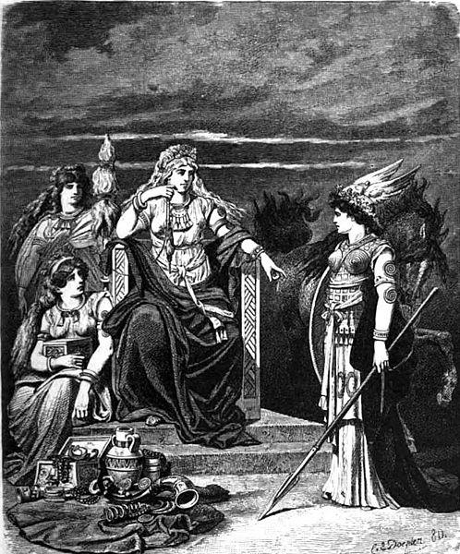

Generated Question - Which god, known as the husband of Frigg, is associated with wisdom, war, and has sons Thor and Baldr?

Generated Answer - Odin is the husband of Frigg, associated with wisdom, war, and father of Thor and Baldr.

--- Entry for custom_id: d5dd0c9e0dba11ecb1e81171463288e9 ---

Example Question - What color are the bill and feet of the bar-tailed trogon and the belly of the male black-throated trogon?

Example Answer - yellow

Image Source 1 -

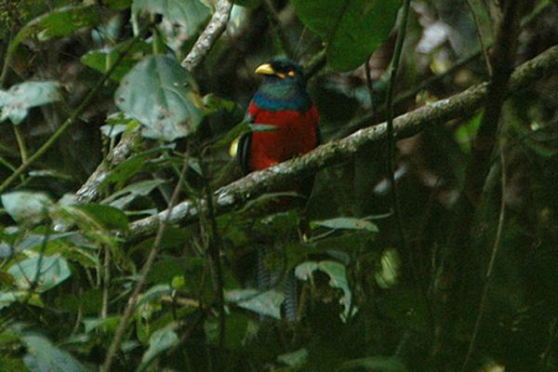

Generated Question - Based on the image and text, which trogon species is shown, and what color is its head?

Generated Answer - The image shows a bar-tailed trogon with a blue-black head.

--- Entry for custom_id: d5ccb01a0dba11ecb1e81171463288e9 ---

Image Source 1 -

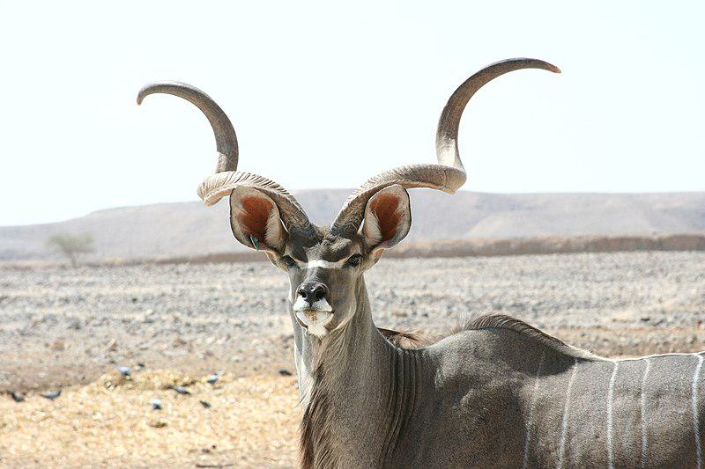

Caption for image source 1: Kudu antelope Kudu at antelpe ranch, Israel.

Example Question - "What shape are the horns of a Kudu Antelope?"

Example Answer - "The horns of the Kudu Antelope are spiral shaped."

Additional Text Source 1 - The procedure is to run down an antelope, such as a kudu, in the midday heat, for up to five hours and a distance of up to 35 km (22 mi) in temperatures of as much as 42 °C (108 °F). (from: Persistence hunting)

Generated Question - How might the spiral shape of the kudu antelope's horns affect its endurance during a long persistence hunt in high heat?

Generated Answer - The spiral horns likely do not affect endurance; the kudu relies on stamina and heat tolerance for persistence hunting.

--- Entry for custom_id: d5bca3140dba11ecb1e81171463288e9 ---

Image Source 1 -

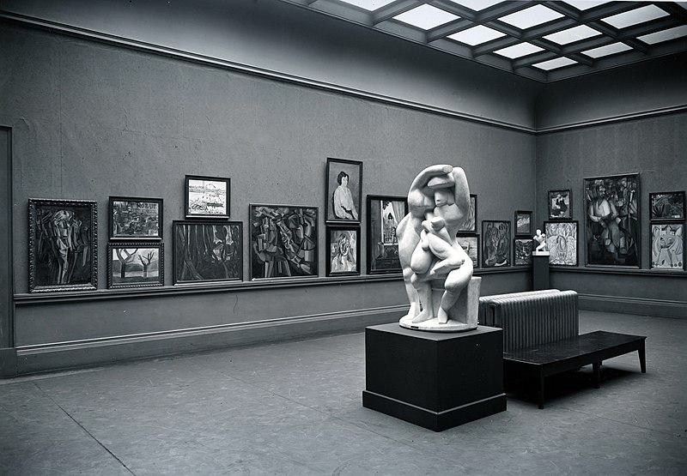

Caption for image source 1: Armory Show, International Exhibition of Modern Art, Chicago, 1913. The Cubist room.

Example Question - "How many sculptures are on display in the Cubist Room at the Armory Show International Exhibition of Modern Art?"

Example Answer - "There are two sculptures on display in the Cubist Room at the Armory Show International Exhibition of Modern Art."

Additional Text Source 1 - The first large scale exhibition of modern art in America this exhibition showcased the artistic movement known as cubism which made artists like Pablo Picasso and Georges Braque so famous. Both Picasso and Braque had paintings on display at the Armory Show. (from: Edith L. King)

Generated Question - Did the Armory Show Cubist Room in Chicago feature artworks by both Picasso and Braque?

Generated Answer - Yes, the Armory Show Cubist Room featured paintings by both Picasso and Braque.

--- Entry for custom_id: d5c704120dba11ecb1e81171463288e9 ---

Image Source 1 -



Caption for image source 1: Mycena parsonsiae 44171.

Image Source 2 -



Caption for image source 2: Mycena leaiana 58075.

Example Question - "What kind of surface can Mycena leaiana and Mycena parsonsiae grow on?"

Example Answer - "They can grow on a rock surface."

Additional Text Source 1 - The pigment responsible for the orange color in this species has antibiotic properties. A variety of the species, Mycena leaiana var. australis, can be found in Australia and New Zealand. (from: Mycena leaiana)

Generated Question - Do both Mycena parsonsiae and Mycena leaiana share the same color and antibiotic pigment properties?

Generated Answer - No, Mycena parsonsiae is brownish, while Mycena leaiana is orange and has antibiotic pigments.

--- Entry for custom_id: d5d43e3e0dba11ecb1e81171463288e9 ---

Example Question - Did Adrien Brody win his Academy Award for Best Actor for The Pianist in the same year that Bill Murray won a Golden Globe award for Lost in Translation?

Example Answer - no

Image Source 1 -



Generated Question - Did Adrien Brody win his Academy Award before Sacha Baron Cohen won his Golden Globe for Best Actor in a Musical or Comedy?

Generated Answer - Yes, Adrien Brody won his Academy Award in 2002, before Sacha Baron Cohen won in 2020.

--- Entry for custom_id: d5cfe1680dba11ecb1e81171463288e9 ---

Example Question - How many vase painters have been identified by people who sometimes studied disjecta membra?

Example Answer - Over 2800 painters have been identified.

Image Source 1 -

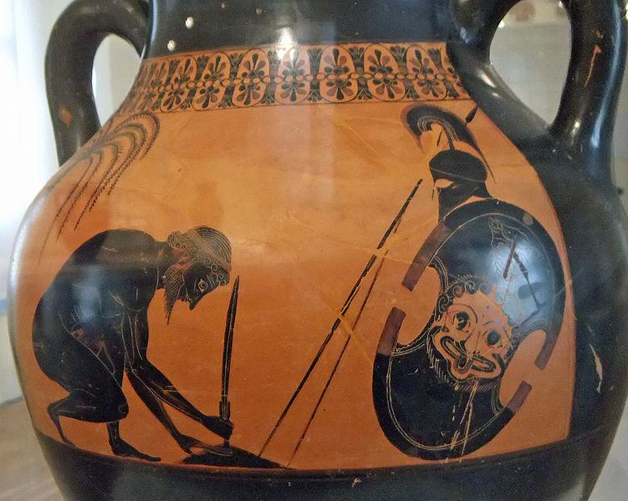

Generated Question - How does the study of disjecta membra contribute to identifying painters like Exekias, who created scenes such as Ajax preparing for his suicide?

Generated Answer - Studying disjecta membra helps attribute fragmented pottery to painters like Exekias, aiding identification of over 2800 artists.

--- Entry for custom_id: d5ccabc40dba11ecb1e81171463288e9 ---

Image Source 1 -

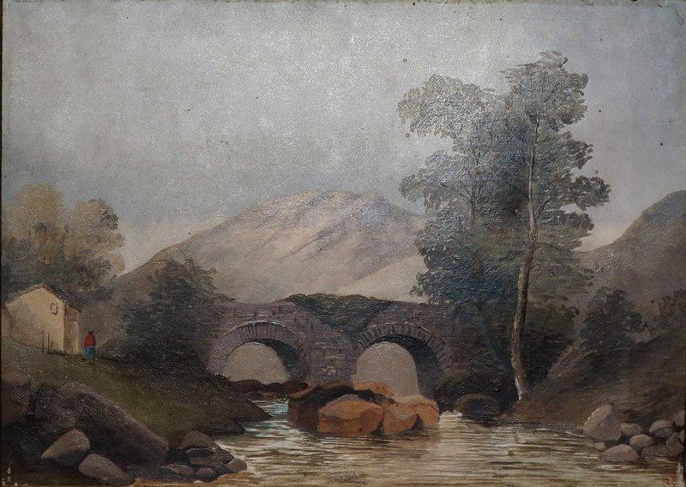

Caption for image source 1: Scottish Landscape, oil on canvas painting by Princess Victoria Kaiulani, c. 1891, Bishop Museum Scottish Landscape, oil on canvas painting by Princess Victoria Kaiulani, c. 1891, Bishop Museum.

Image Source 2 -

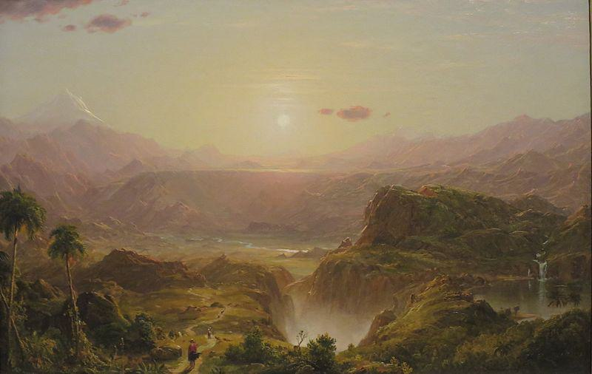

Caption for image source 2: 'The Andes of Ecuador', oil on canvas painting by Frederic Adwin Church, 1855, HAA The Andes of Ecuador oil on canvas painting by Frederic Edwin Church, 1855, Honolulu Museum of Art accession 56221.

Example Question - "In which painting is the sun visible: The Andes of Ecuador by Frederic Adwin Church or Scottish Landscape by by Princess Victoria Kaiulani?"

Example Answer - "The sun visible in the painting The Andes of Ecuador by Frederic Adwin Church."

Additional Text Source 1 - Theodore Winthrop's A Companion to The Heart of the Andes and the Reverend Louis Legrand Noble's Church's Picture, The Heart of the Andes. In the manner of travel guides, the booklets provided a tour of the painting's varied topography. (from: The Heart of the Andes)

Generated Question - Which painting depicts a more detailed and varied topography suitable for a travel guide, Scottish Landscape or The Andes of Ecuador?

Generated Answer - The Andes of Ecuador depicts a more detailed and varied topography suitable for a travel guide.

--- Entry for custom_id: d5c6d0aa0dba11ecb1e81171463288e9 ---

Image Source 1 -

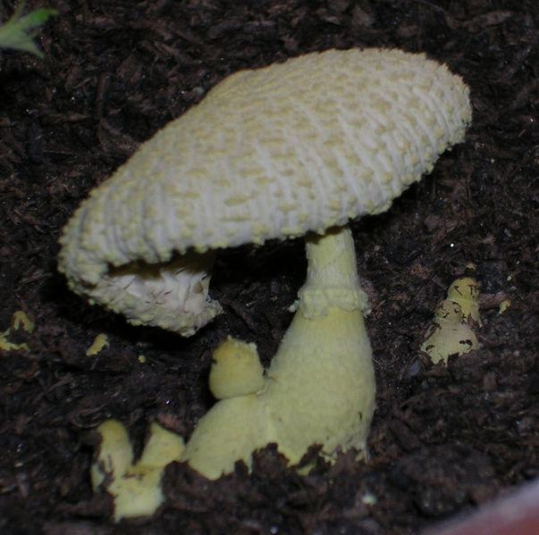

Caption for image source 1: Leucocoprinus birnbaumii.

Image Source 2 -



Caption for image source 2: Laccaria amethysteo-occidentalis (32942930552).

Example Question - "Which fungus top looks most like it was knit; Leucocoprinus birnbaumii or Laccaria amethysteo-occidentalis?"

Example Answer - "The Leucocoprinus birnbaumii fungus top looks most like it was knit."

Additional Text Source 1 - Fruit bodies of Leucocoprinus birnbaumii are agaricoid (mushroom-shaped) and occur singly or in small clumps. All parts are bright, pale sulphur-yellow, but fade with age. (from: Leucocoprinus birnbaumii)

Generated Question - Which fungus is more likely to be found in small clumps and has a bright pale sulphur-yellow color, Leucocoprinus birnbaumii or Laccaria amethysteo-occidentalis?

Generated Answer - Leucocoprinus birnbaumii is more likely to be found in small clumps and has a bright pale sulphur-yellow color.

--- Entry for custom_id: d5c9a97e0dba11ecb1e81171463288e9 ---

Image Source 1 -

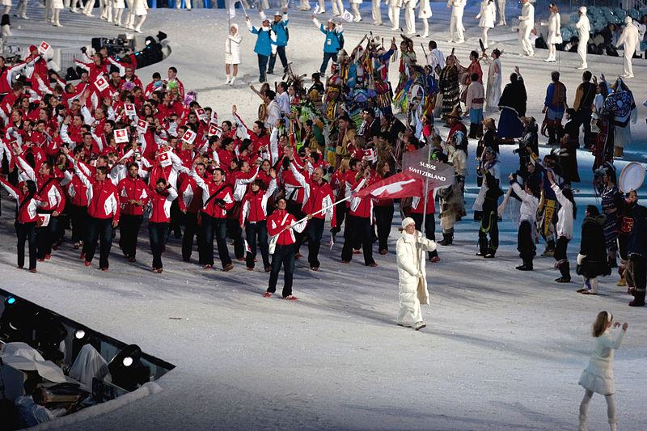

Caption for image source 1: 2010 Opening Ceremony - Switzerland entering.

Image Source 2 -

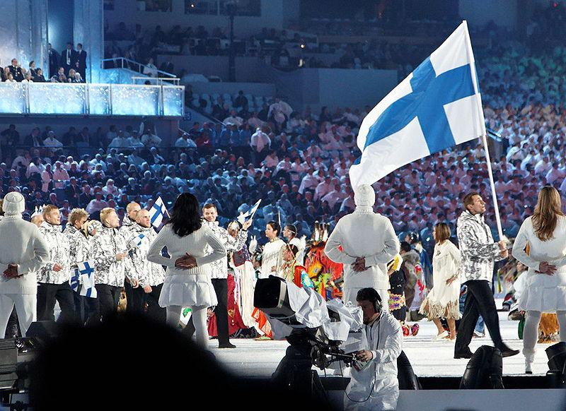

Caption for image source 2: 2010 Olympic Winter Games Opening Ceremony - Finland entering cropped.

Example Question - "Which nation in the 2010 Winter Olympics opening ceremony had more white in their uniforms: Finland or Switzerland?"

Example Answer - "Finland had more white in their uniforms than Switzerland."

Additional Text Source 1 - The broadcast attracted 31.7 million American viewers, compared to 32.6 million for the live telecast of the 2010 Winter Olympics opening ceremony. (from: 2014 Winter Olympics opening ceremony)

Generated Question - Considering the 2010 Winter Olympics opening ceremony, which country's team uniforms contrasted more with the snowy ground, Switzerland or Finland?

Generated Answer - Switzerland's red and white uniforms contrasted more with the snowy ground than Finland's mostly white uniforms.

--- Entry for custom_id: d5cfb54e0dba11ecb1e81171463288e9 ---

Example Question - What was the name of the home arena to the Texas Stars of the American Hockey League when WrestleMania 29 took place?

Example Answer - Cedar Park Center

Image Source 1 -

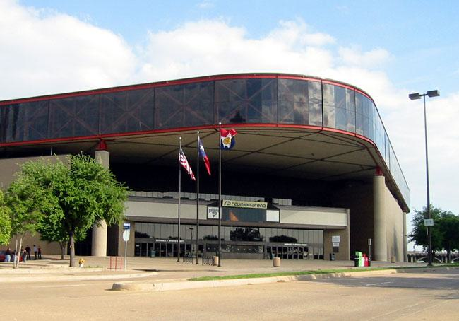

Generated Question - Did the Texas Stars move from Reunion Arena to the Cedar Park Center after 2001?

Generated Answer - Yes, they moved from Reunion Arena to Cedar Park Center after 2001.

--- Entry for custom_id: d5c449c00dba11ecb1e81171463288e9 ---

Image Source 1 -

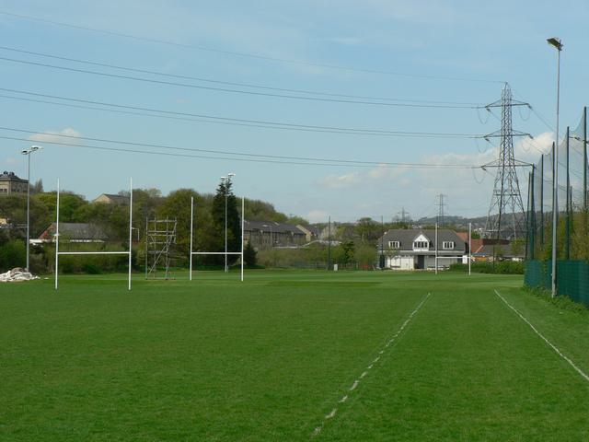

Caption for image source 1: Leeds Rugby Academy, Kirkstall - geograph.org.uk - 165339 Leeds Rugby Academy, Kirkstall. Looking along the fence on the east side adjacent to Morrisons..

Image Source 2 -

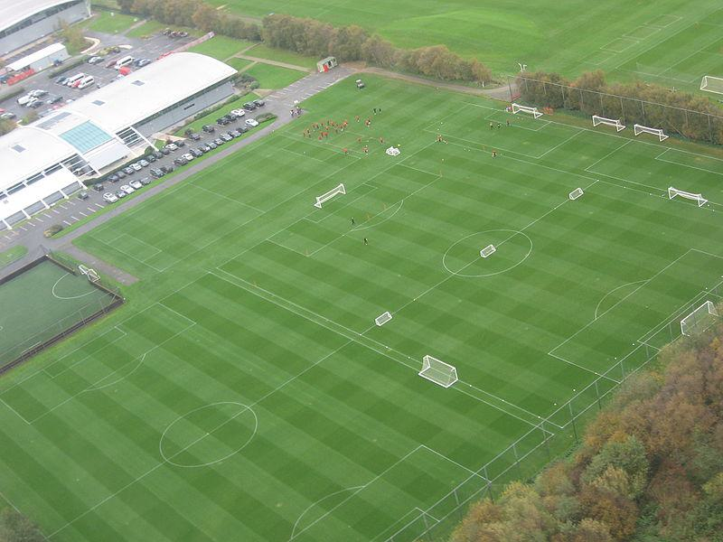

Caption for image source 2: MUFC training ground Carrington.

Example Question - "Are there light posts next to the field at both Leeds rugby Academy in kirkstall and the MUFC training ground in Carrington?"

Example Answer - "No, there are no light posts next to the field at Leeds rugby Academy in Kirkstall or the MUFC training ground in Carrington."

Additional Text Source 1 - It is near the village of Carrington, Greater Manchester, England, and replaced The Cliff as the club's training ground in 2000. Construction on the complex began in 1999, the main building was opened and the first team moved in in 2000, followed in 2002 by the Academy facility, home to the club's renowned youth system. (from: Trafford Training Centre)

Generated Question - Do both Leeds Rugby Academy and MUFC training ground have rugby goalposts on their fields?

Generated Answer - No, only Leeds Rugby Academy has rugby goalposts; MUFC training ground has soccer goals.

--- Entry for custom_id: d5c3d3960dba11ecb1e81171463288e9 ---

Image Source 1 -

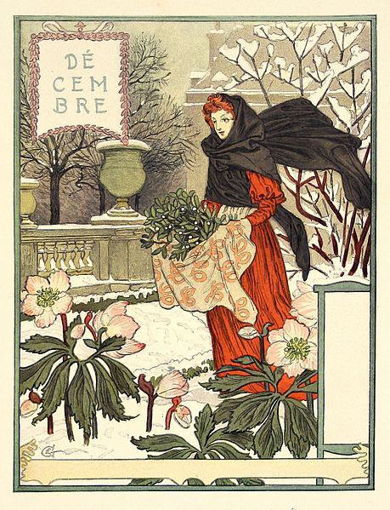

Caption for image source 1: Grasset-decembre.

Image Source 2 -

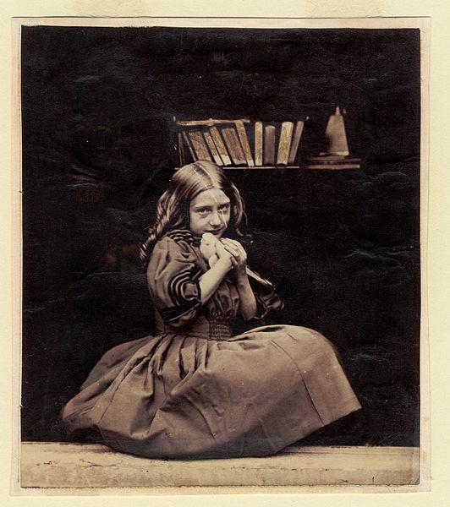

Caption for image source 2: Rejlander045 No title.

Example Question - "Which painting is more colorful, the "Decembre" by Eugène Grasset or the "Girl with dove" by Oscar Gustave Rejlander?"

Example Answer - "Decembre is more colorful than Girl with dove."

Additional Text Source 1 - In 1877 Eugène Grasset turned to graphic design, producing income-generating products such as postcards and eventually postage stamps for both France and Switzerland. (from: Eugène Grasset)

Generated Question - Considering Eugène Grasset's work in graphic design, which image better represents his colorful style, "Decembre" or "Girl with dove"?

Generated Answer - "Decembre" better represents Eugène Grasset's colorful graphic design style.

--- Entry for custom_id: d5d1f1060dba11ecb1e81171463288e9 ---

Example Question - What is the weight range for squids that are part of the Cephalopod molluscs phylum?

Example Answer - They can range in weight between 0.1 kg to 495 kg.

Image Source 1 -

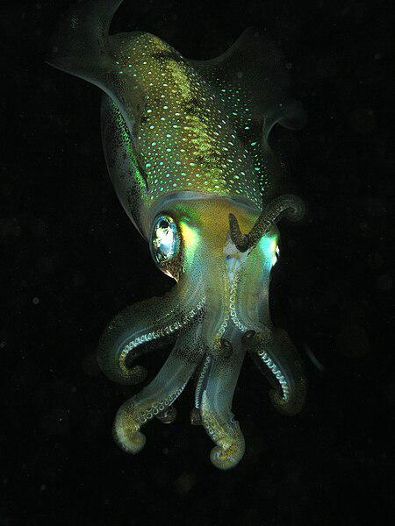

Generated Question - Considering the colossal squid's weight and the cephalopod's temporal range, how long have cephalopods existed compared to the squid's size evolution?

Generated Answer - Cephalopods have existed since the Late Cambrian, evolving to include giant squids weighing up to 495 kg.

--- Entry for custom_id: d5c40a8c0dba11ecb1e81171463288e9 ---

Image Source 1 -

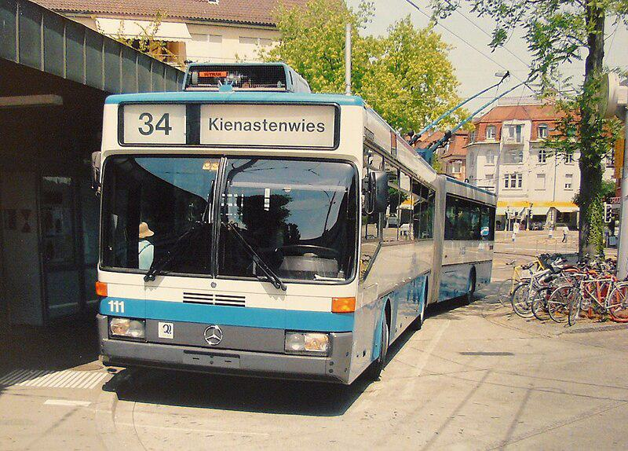

Caption for image source 1: Klausplatz Zurich trolleybus Mercedes-Benz trolleybus (#111) at Klusplatz in Zurich, Switzerland..

Example Question - "What brand of buses are used at Klusplatz in Zurich, Switzerland?"

Example Answer - "The buses at Klusplatz in Zurich, Switzerland are Mercedes Benz."

Additional Text Source 1 - The next major event for the airport was in 1999, when the Parliament of the canton of Zürich approved privatization of Zurich Airport. The following year, Flughafen Zürich AG, trading under the brand Unique, became the new airport operator. (from: Zurich Airport)

Generated Question - Is the Mercedes-Benz trolleybus at Klausplatz in Zurich likely connected to the privatized Zurich Airport operated by Flughafen Zürich AG?

Generated Answer - No, the trolleybus at Klausplatz is a city transport vehicle, separate from Zurich Airport operations.

--- Entry for custom_id: d5d0f5c60dba11ecb1e81171463288e9 ---

Example Question - On what highway in California were there cars overturned during the outbreak of weak tornadoes in Santa Barbara and Orange Counties between January 19 and January 21, 2010?

Example Answer - The cars were overturned on the Pacific Coast Highway.

Image Source 1 -

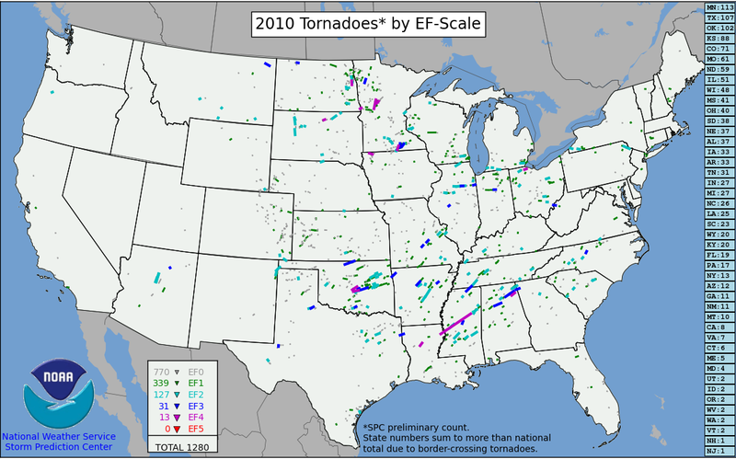

Generated Question - Did the tornado outbreak in Southern California between January 19 and 21, 2010, contribute significantly to the total number of tornadoes shown on the 2010 U.S. tornado map?

Generated Answer - No, the Southern California outbreak was weak and contributed only a few tornadoes to the total.

--- Entry for custom_id: d5d0210a0dba11ecb1e81171463288e9 ---

Example Question - What title can the older youth of the Sea Scouts elect a youth leader to that is also a member of a U.S. Navy gun crew?

Example Answer - They can be given the title 'boatswain".

Image Source 1 -

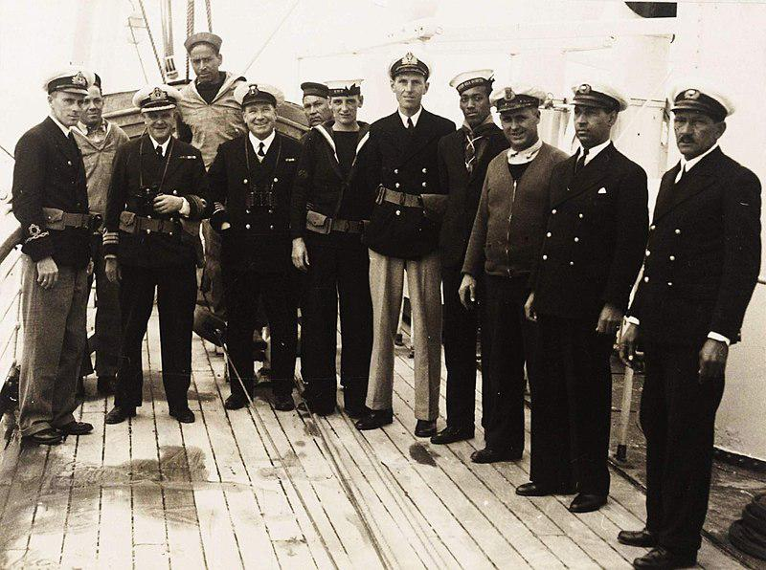

Generated Question - Which rank from the Sea Scouts could the fourth person from the right in the HMS Castle Harbour crew photo possibly hold, based on the Navy and Sea Scout roles?

Generated Answer - The rank of boatswain.

--- Entry for custom_id: d5dde1d20dba11ecb1e81171463288e9 ---

Example Question - Egbert Benson and John Jay had descent from what people whose colonization of the Americas began with the establishment of trading posts and plantations?

Example Answer - Dutch

Image Source 1 -

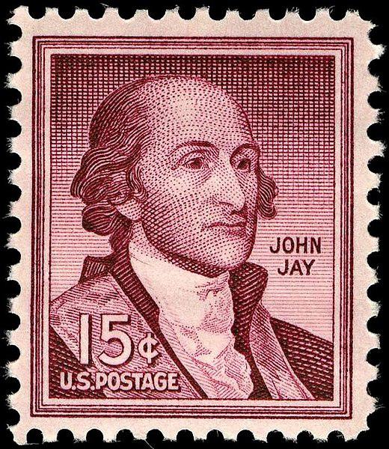

Generated Question - Which colonizing people, known for early American trading posts, were the ancestors of John Jay featured on the 15¢ postage stamp?

Generated Answer - Dutch

--- Entry for custom_id: d5cc0cc80dba11ecb1e81171463288e9 ---

Image Source 1 -

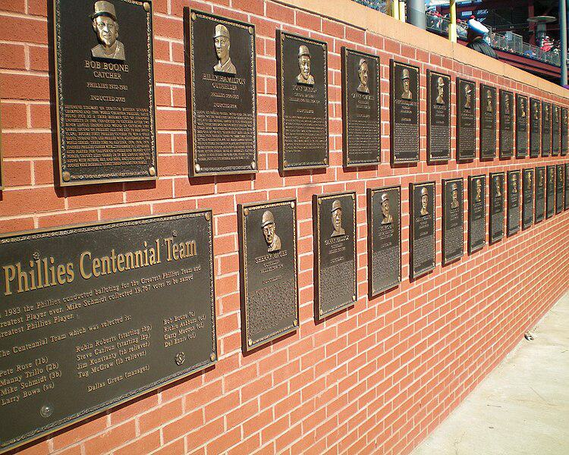

Caption for image source 1: PhilliesWallofFame This is the Phillies Wall of Fame at Citizens Bank Park, Philadelphia, PA..

Example Question - "What kind of wall holds the Phillies Wall of Fame at Citizens Bank Park, Philadelphia, PA?"

Example Answer - "A brick wall holds the Phillies Wall of Fame at Citizens Bank Park, Philadelphia, PA."

Additional Text Source 1 - The Philadelphia Baseball Wall of Fame is a collection of plaques, mounted on a brick wall next to the Left Field Gate at Citizens Bank Park, the ballpark of the Philadelphia Phillies. (from: Philadelphia Baseball Wall of Fame)

Generated Question - Are the plaques on the Phillies Wall of Fame at Citizens Bank Park arranged in multiple rows on the brick wall?

Generated Answer - Yes, the plaques are arranged in multiple rows on the brick wall.

--- Entry for custom_id: d5c0f2f20dba11ecb1e81171463288e9 ---

Image Source 1 -

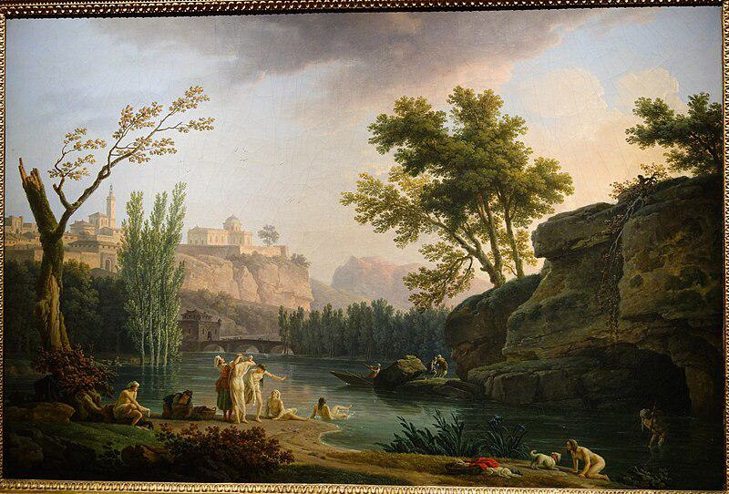

Caption for image source 1: Summer Evening, Landscape in Italy, view 2, by Joseph Vernet, 1773, oil on canvas - National Museum of Western Art, Tokyo - DSC08554 Painting in the National Museum of Western Art, Tokyo, Japan. This artwork is in the public domain because the artist died more than 70 years ago. Photography was permitted in the museum without restriction..

Image Source 2 -

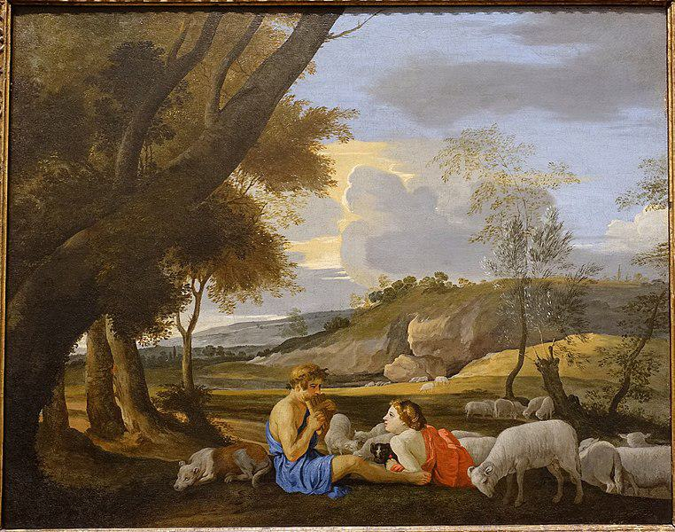

Caption for image source 2: Arcadian Landscape, by the circle of Nicolas Poussin, c. 1627-1628, oil on canvas - Blanton Museum of Art - Austin, Texas - DSC07880 Arcadian Landscape.

Example Question - "Is there a dog in Joseph Vernet's "Summer Evening, Landscape in Italy" and "Arcadian Landscape, by the circle of Nicolas Poussin"?"

Example Answer - "There is a dog in both Joseph Vernet's "Summer Evening, Landscape in Italy" and "Arcadian Landscape, by the circle of Nicolas Poussin"."

Additional Text Source 1 - By his absolute humility, by his effacement of himself, by his refusal to use any tricks or overstate himself, Poussin has succeeded in identifying himself with nature, conceived as a manifestation of the divine reason. The Seasons are among the supreme examples of pantheistic landscape painting. (from: The Four Seasons (Poussin))

Generated Question - Do both paintings depict natural landscapes with human figures interacting peacefully with animals?

Generated Answer - Yes, both paintings show humans peacefully interacting with animals in natural landscapes.

--- Entry for custom_id: d5d60a980dba11ecb1e81171463288e9 ---

Example Question - According to legend, Dangun founded the first kingdom in what place where monarchy existed until the end of the Japanese occupation?

Example Answer - Korea

Image Source 1 -



Generated Question - In which country, where monarchy ended after Japanese occupation, is the 2012 Victory Day rehearsal in Pyongyang held?

Generated Answer - North Korea

--- Entry for custom_id: d5d9ed700dba11ecb1e81171463288e9 ---

Example Question - The high peak called Golden Hinde can be found in what area that the twin summits the Lions Gate Bridge was named in their honor are in?

Example Answer - Vancouver.

Image Source 1 -

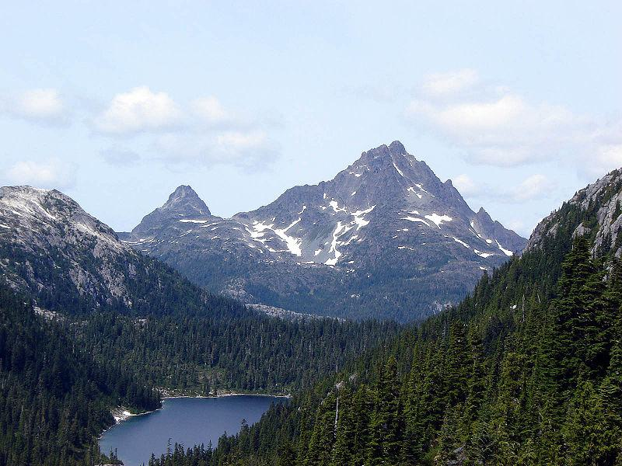

Generated Question - Are the Golden Hinde and the Lions peaks both visible from the Greater Vancouver area?

Generated Answer - No, only the Lions peaks are visible from Greater Vancouver, not the Golden Hinde.

--- Entry for custom_id: d5c555a40dba11ecb1e81171463288e9 ---

Image Source 1 -

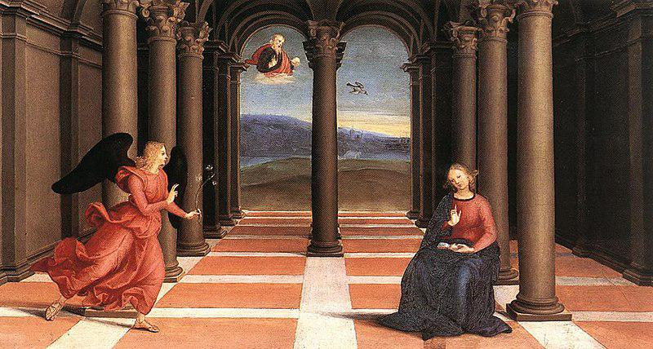

Caption for image source 1: Raphael - The Annunciation (Oddi altar).

Example Question - "What is the angel in The Annunciation Oddi altar holding in her hand?"

Example Answer - "The angel in The Annunciation Oddi Alter is holding an olive branch."

Image Source 2 -



Generated Question - Does the architectural style in Raphael's The Annunciation Oddi altar contrast with the natural ruggedness of the mountains on Vancouver Island?

Generated Answer - Yes, Raphael's structured classical architecture contrasts with the rugged natural mountains of Vancouver Island.

--- Entry for custom_id: d5d1e0e40dba11ecb1e81171463288e9 ---

Example Question - Does relation of ideas impact relational theory?

Example Answer - It does not.

Image Source 1 -



Generated Question - How does the relational model concept in the image illustrate the idea that properties are meaningful only relative to other objects in relational theory?

Generated Answer - The relational model shows attributes and values as dependent on the relation variable, reflecting properties relative to other objects.

--- Entry for custom_id: d5c31f1e0dba11ecb1e81171463288e9 ---

Image Source 1 -

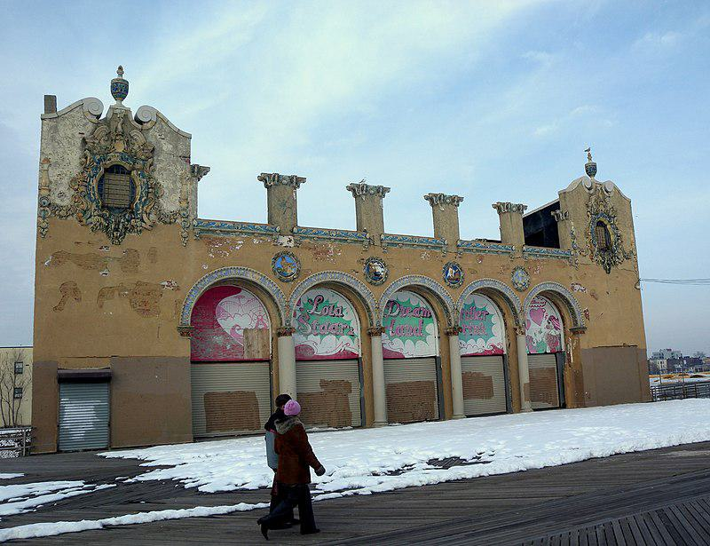

Caption for image source 1: Childs Restaurant CI jeh Looking north at former Childs Restaurant on a cloudy New Years Day after the Polar Bear plunge..

Image Source 2 -

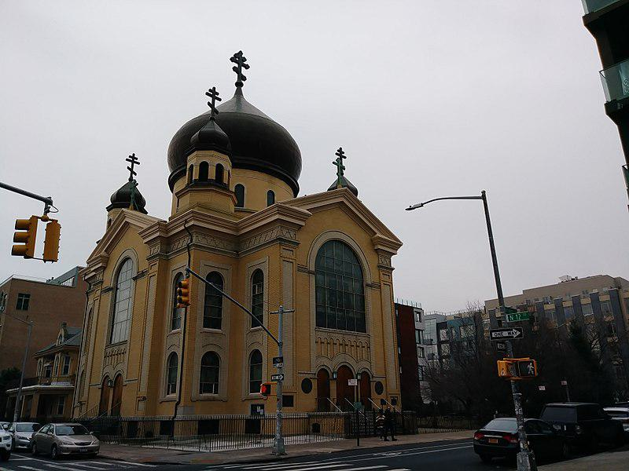

Caption for image source 2: Cathedral of the Transfiguration of Our Lord (28407618089).

Example Question - "What color is both the Cathedral of the Transfiguration of Our Lord Building and the Child's Restaurant Building?"

Example Answer - "The Cathedral of the Transfiguration of Our Lord building and the Child's Restaurant building are both brown."

Additional Text Source 1 - Russian Orthodox Cathedral of the Transfiguration of Our Lord is a historic Russian Orthodox cathedral at 228 North 12th Street in the Williamsburg neighborhood of Brooklyn, New York City. (from: Russian Orthodox Cathedral of the Transfiguration of Our Lord)

Generated Question - Are both the Childs Restaurant and the Russian Orthodox Cathedral located in Brooklyn, New York City?

Generated Answer - Yes, both buildings are located in Brooklyn, New York City.

--- Entry for custom_id: d5dacd620dba11ecb1e81171463288e9 ---

Example Question - What type of rimless bottlenecked rifle cartridge was developed in the 1950's that the general purpose machine gun designated the General Support Machine Gun (GSMG) is chambered for?

Example Answer - 7.62x51mm NATO

Image Source 1 -

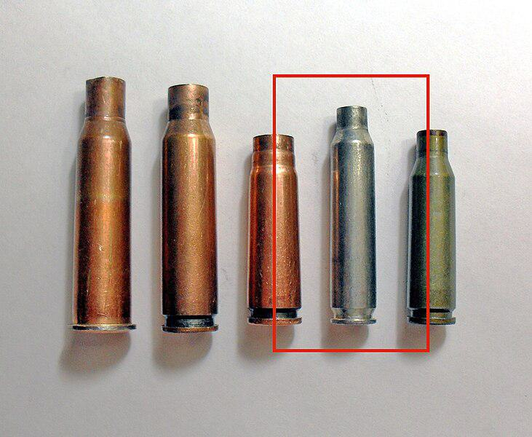

Generated Question - Which rimless cartridge shown in the image is used by the General Support Machine Gun (GSMG) that replaced the M60 machine gun?

Generated Answer - The 7.62×51mm NATO cartridge.

--- Entry for custom_id: d5cd7d420dba11ecb1e81171463288e9 ---

Image Source 1 -

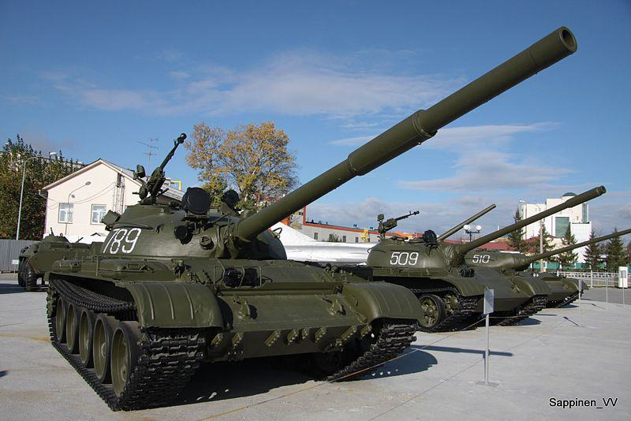

Caption for image source 1: Verkhnyaya Pyshma Tank Museum 2012 0071 Verkhnyaya Pyshma Tank Museum 2012.

Example Question - "What are some numbers of the tanks at the Verkhnyaya Pyshma Tank Museum?"

Example Answer - "The numbers of the tanks at the Verkhnyaya Pyshma Tank Museum are 789, 509 and 510."

Additional Text Source 1 - The museum's collection also includes some American equipment (including Sherman and Stuart tanks) sent to the Soviet Union as part of Lend-Lease. (from: UMMC Museum of Military and Automotive Equipment)

Generated Question - Are the tanks numbered 789, 509, and 510 at the Verkhnyaya Pyshma Tank Museum likely Soviet or American models based on the museum's collection?

Generated Answer - They are likely Soviet models, as the museum also includes American tanks separately.

--- Entry for custom_id: d5df50b20dba11ecb1e81171463288e9 ---

Example Question - Merlangius merlangus and Coregonus clupeaformis are both types of what?

Example Answer - Fish

Image Source 1 -

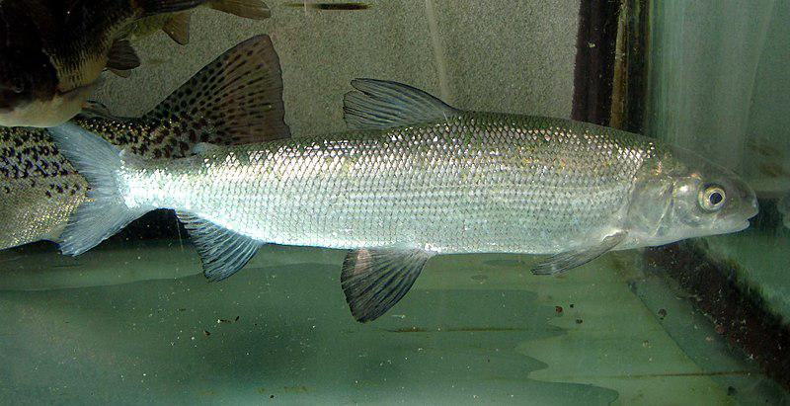

Generated Question - Are Coregonus clupeaformis and Coregonus lavaretus both freshwater fish found in northern regions?

Generated Answer - Yes, both are freshwater fish found in northern regions.

--- Entry for custom_id: d5ded43e0dba11ecb1e81171463288e9 ---

Example Question - The nobility of what country that party sponsored exploratory voyages can be traced back to Alfonso VI of Leon?

Example Answer - Portugal.

Image Source 1 -



Generated Question - Which nobility, Portuguese or Spanish, is linked to explorers like João Vaz Corte-Real and which is represented by the house of Alcantara?

Generated Answer - Portuguese nobility is linked to explorers like João Vaz Corte-Real, while the house of Alcantara represents Spanish high nobility.

--- Entry for custom_id: d5d115100dba11ecb1e81171463288e9 ---

Example Question - Which more clearly defines a belief that just about anything has a spirit; Religion or Animism?

Example Answer - Animism

Image Source 1 -

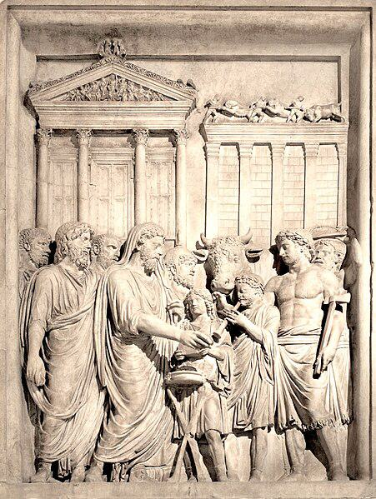

Generated Question - Does the ancient Roman religious practice shown in the image align more with a shared belief system or with animism's view of spirits in all things?

Generated Answer - It aligns more with a shared belief system as a formal religion.

--- Entry for custom_id: d5dc26bc0dba11ecb1e81171463288e9 ---

Example Question - What is the more common form of hermaphroditism of producing reproductive cells at different life stages, where a born female changes into a male some time?

Example Answer - Protogynous hermaphrodites.

Image Source 1 -

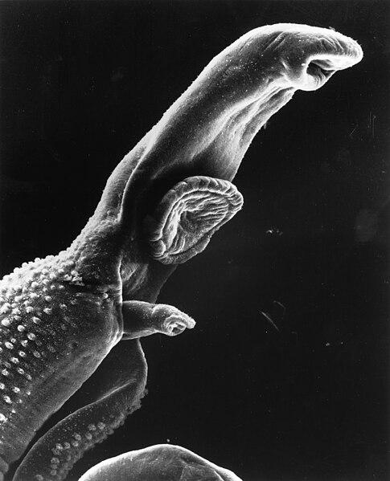

Generated Question - How does the reproductive strategy of schistosomes differ from protogynous hermaphrodites described in the text?

Generated Answer - Schistosomes are gonochoric, having separate sexes, unlike protogynous hermaphrodites that change sex during life.

--- Entry for custom_id: d5c88f760dba11ecb1e81171463288e9 ---

Image Source 1 -

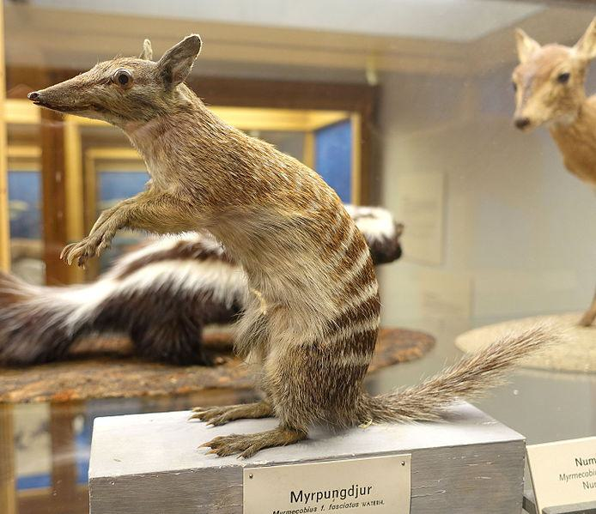

Caption for image source 1: Myrmecobius fasciatus - Swedish Museum of Natural History - Stockholm, Sweden - DSC00656 Exhibit in the Swedish Museum of Natural History - Stockholm, Sweden. Photography was permitted in the museum without restriction..

Image Source 2 -



Caption for image source 2: Siberian Chipmunk (Tamias sibiricus), Parc du Rouge-Cloître, Forêt de Soignes, Brussels (26040359560).

Example Question - "Is the snout of the Siberian Chipmunk longer relative to its body than the snout of the Myrmecobius Fasciatus?"

Example Answer - "No, the snout of the Siberian Chipmunk is not longer relative to its body than the snout of the Myrmecobius Fasciatus."

Additional Text Source 1 - Even though the Siberian chipmunk normally grows to 50–150 grams (1.8–5.3 oz), this species is relatively small compared to other Sciuridae, such as the red squirrel. The Siberian chipmunks are not known to exhibit sexual dimorphism, and size and body proportions are the only way to distinguish younger chipmunks from older ones. (from: Siberian chipmunk)

Generated Question - Considering their body proportions, which animal has a more elongated snout relative to its body, the Myrmecobius fasciatus or the Siberian chipmunk?

Generated Answer - The Myrmecobius fasciatus has a more elongated snout relative to its body than the Siberian chipmunk.

--- Entry for custom_id: d5c2ab420dba11ecb1e81171463288e9 ---

Image Source 1 -



Caption for image source 1: WardenT&T T & T at Warden Centre in Markham.

Example Question - "What colors are used for the lettering sign on the front of the T&T Supermarket building in Markham?"

Example Answer - "The lettering on the sign for the T&T Supermarket in Markham is red, white, and green."

Additional Text Source 1 - The company's supermarket brands are Lianhua Supermarket and Hualian Supermarket (S: 华联超市, T: 華聯超市, P: Huálián Chāoshì). Its convenience store brand is Lianhua Quik (C: 快客便利, P: Kuàikè Biànlì). (from: Lianhua Supermarket)

Generated Question - Is the T&T Supermarket in Markham related to the Lianhua Supermarket brand mentioned in the additional text source?

Generated Answer - No, T&T Supermarket and Lianhua Supermarket are different brands.

--- Entry for custom_id: d5c11ab60dba11ecb1e81171463288e9 ---

Image Source 1 -



Caption for image source 1: NNC-US-1796-G$2½-Turban Head (no stars) 1796 G$2 Turban Head (or Capped Bust) (no stars)Gold (fineness 0.9160), 20mm, 4.37g, designed by Robert ScotJN2015-6714-15.

Example Question - "Does the head on the Turban Head coin have long or short hair?"

Example Answer - "The head on the Turban Head coin has long hair."

Additional Text Source 1 - Also known as the "Turban Head", this interpretation of Liberty wearing a turban-like cap was designed by Robert Scot and was minted from 1796 to 1807, for a total of less than 20,000 coins minted. (from: Quarter eagle)

Generated Question - Was the Turban Head coin minted for more than a decade and does it feature Liberty with a turban-like cap?

Generated Answer - Yes, it was minted from 1796 to 1807 and features Liberty wearing a turban-like cap.

--- Entry for custom_id: d5cd57d60dba11ecb1e81171463288e9 ---

Image Source 1 -

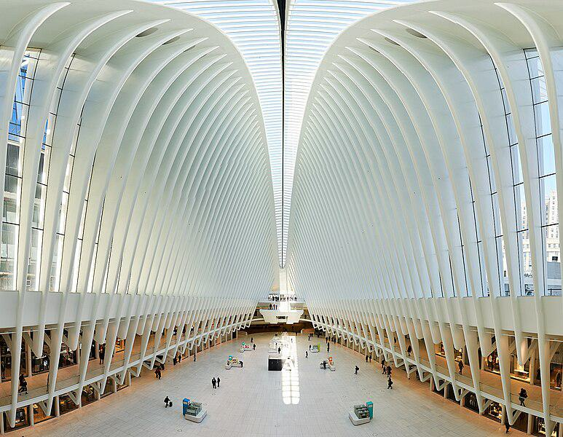

Caption for image source 1: Westfield Mall The Westfield Mall in One World Trade Center in New York CIty..

Example Question - "Are all the white ribs in the Westfield Mall in One World Trade Center in New York City the same length?"

Example Answer - "No, all of the white ribs in the Westfield Mall in the One World Trade Center in New York City do not have the same length."

Additional Text Source 1 - The renovated entrance, leading to the New York City Subway station from the Oculus headhouse and the Westfield World Trade Center, opened on December 19, 2016. (from: World Trade Center station (PATH))

Generated Question - Does the Westfield Mall in One World Trade Center have a direct connection to the New York City Subway station through the Oculus headhouse?

Generated Answer - Yes, the Westfield Mall connects directly to the subway via the Oculus headhouse.

--- Entry for custom_id: d5c32cc00dba11ecb1e81171463288e9 ---

Image Source 1 -

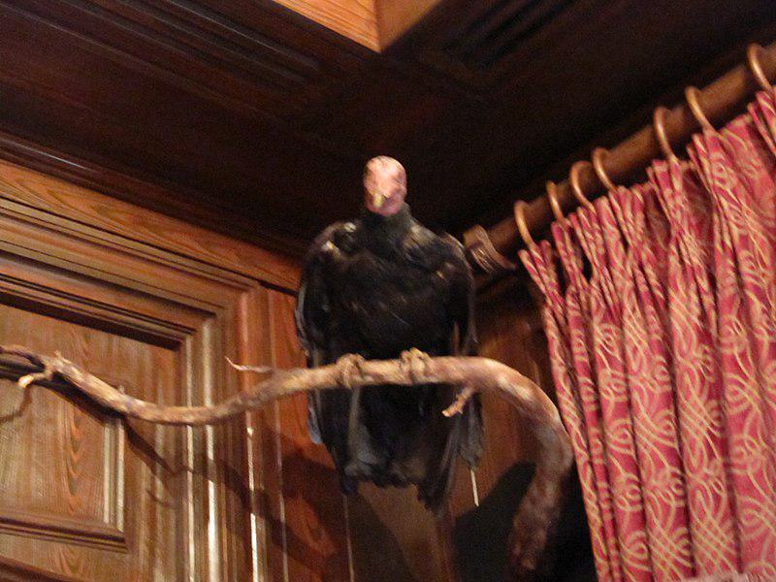

Caption for image source 1: Club 33 Vulture 2010.

Example Question - "What does the vulture hang between in Club 33?"

Example Answer - "The vulture hangs between the door and the curtains in club 33."

Additional Text Source 1 - The governing body of the club is the Club Board (sometimes called Club Council), consisting of the club president (who serves as the Board chairman), a president-elect, club secretary, club treasurer, and several Club Board directors, including the immediate past president and the President Elect. (from: Rotary International)

Generated Question - Is the vulture in Club 33 positioned near any wooden structures and fabric decorations?

Generated Answer - Yes, the vulture is positioned near wooden panels and red patterned curtains.

--- Entry for custom_id: d5ca8dda0dba11ecb1e81171463288e9 ---

Image Source 1 -



Caption for image source 1: Men's 200 metres event at the 2016 Summer Olympics, Olympic Stadium (Engenhão), Rio de Janeiro, Brazil (cropped) Men's 200 metres event at the 2016 Summer Olympics, Olympic Stadium (Engenhao), Rio de Janeiro, Brazil..

Image Source 2 -



Caption for image source 2: Spc. Paul Chelimo wins silver medal in 5,000 meters at Rio Olympic Games photos by Tim Hipps, IMCOM Public Affairs (29090421706).

Example Question - "In the 5,000 and 200 meters events at the Rio Olympic Games, did the athletes wear their country's name across their chest?"

Example Answer - "Yes, they wore their country's name across their chest."

Additional Text Source 1 - Wilson had not previously participated in any Olympic games or events. During the August 17 qualification round, Wilson was placed in the second heat and placed third out of the heat's seventh athletes after finishing the race in 55.75 seconds. (from: Jamaica at the 2008 Summer Olympics)

Generated Question - Did athletes in both the 200 meters and 5,000 meters events at the Rio Olympics wear bib numbers during their races?

Generated Answer - Yes, athletes in both events wore bib numbers during their races.

--- Entry for custom_id: d5c43bec0dba11ecb1e81171463288e9 ---

Image Source 1 -

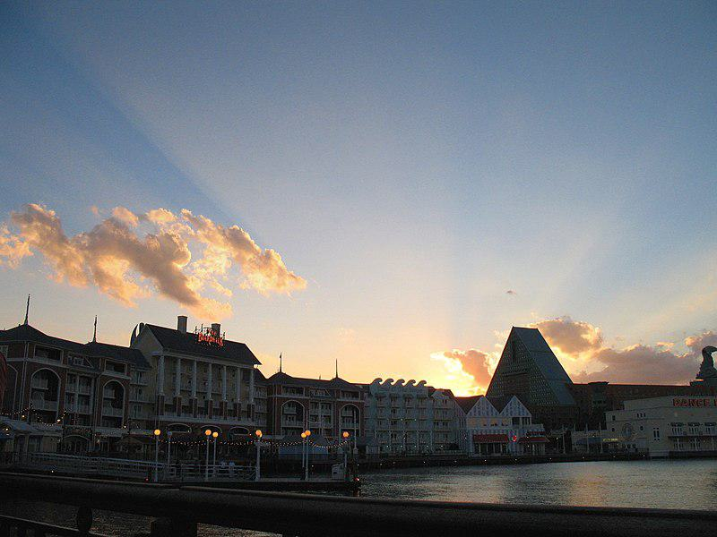

Caption for image source 1: DISNEYWORLD BOARDWALK RESORT - panoramio.

Image Source 2 -



Caption for image source 2: Coronado Blue (33706136420).

Example Question - "Are Disney's Coronado Springs Resort and Disneyworld's Boardwalk Resort both located on the water?"

Example Answer - "Yes, Disney's Coronado Springs Resort and Disneyworld's Boardwalk Resort are both located on the water."

Additional Text Source 1 - The resort comprises four theme parks (consisting of the Magic Kingdom, Epcot, Disney's Hollywood Studios, and Disney's Animal Kingdom), two water parks, 27 themed resort hotels, nine non-Disney hotels, several golf courses, a camping resort, and other entertainment venues, including the outdoor shopping center Disney Springs. (from: Walt Disney World)

Generated Question - Are both Disney's Boardwalk Resort and Coronado Springs Resort part of the 27 themed resort hotels at Walt Disney World?

Generated Answer - Yes, both resorts are among the 27 themed resort hotels at Walt Disney World.

--- Entry for custom_id: d5d1f34a0dba11ecb1e81171463288e9 ---

Example Question - What literature has a number of Germanic gods mentioned in it that can include Týr and Ullr?

Example Answer - Old Norse.

Image Source 1 -

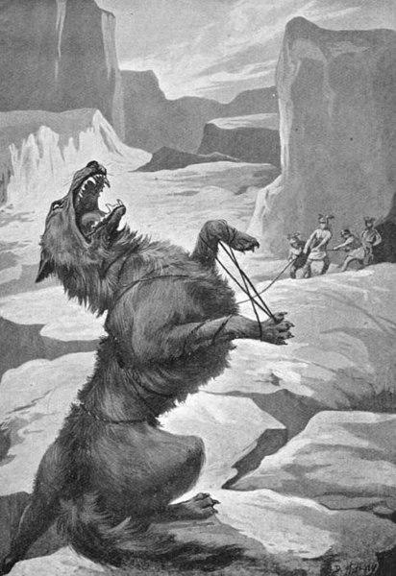

Generated Question - Which group of Germanic gods, including Odin, would likely be responsible for binding Fenrir as shown in the image?

Generated Answer - The Æsir, the gods of war including Odin, bound Fenrir.

--- Entry for custom_id: d5ccad4a0dba11ecb1e81171463288e9 ---

Image Source 1 -

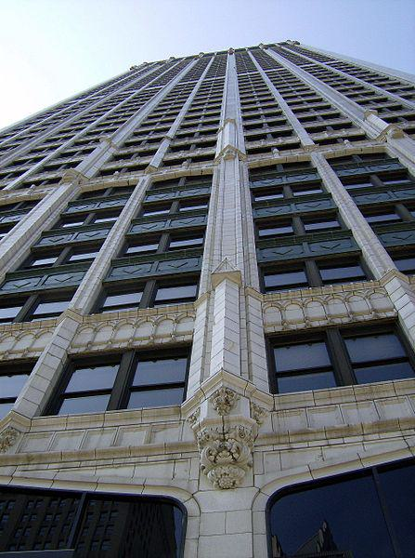

Caption for image source 1: CadillaclookingupDetroit Cadillac Tower in Detroit, Michigan, United States..

Image Source 2 -

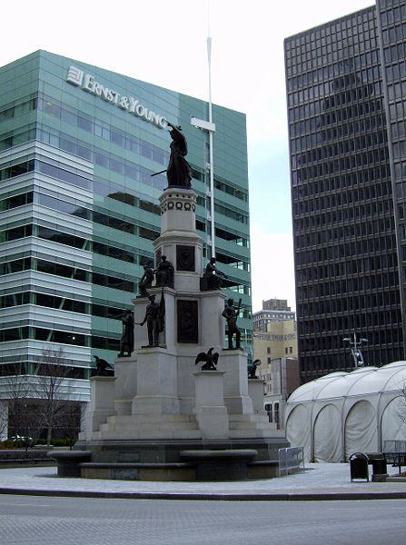

Caption for image source 2: MichiganSoldiersSailors.

Example Question - "Is the Stone on the Michigan Soldiers & Sailors Monument the same Shade of Grey as the facade of the Cadillac building in Detroit?"

Example Answer - "No, the Stone on the Michigan Soldiers & Sailors Monument is not the same Shade of Grey as the facade of the Cadillac building in Detroit."

Additional Text Source 1 - The Cuyahoga County Soldiers' and Sailors' Monument is a major Civil War monument in Cleveland, Ohio, honoring the more than 9,000 individuals from Cuyahoga County who served the Union throughout the war. It was dedicated on July 4, 1894 and is located on the southeast quadrant of Public Square in Downtown Cleveland. (from: Soldiers' and Sailors' Monument (Cleveland))

Generated Question - Are the Michigan Soldiers & Sailors Monument and the Cuyahoga County Soldiers' and Sailors' Monument located in the same city?

Generated Answer - No, the Michigan Soldiers & Sailors Monument is in Detroit, and the Cuyahoga County Monument is in Cleveland.

--- Entry for custom_id: d5d5bade0dba11ecb1e81171463288e9 ---

Example Question - Libor which is calculated by the Intercontinental Exchange stands for what?

Example Answer - London Inter-bank Offered Rate

Image Source 1 -

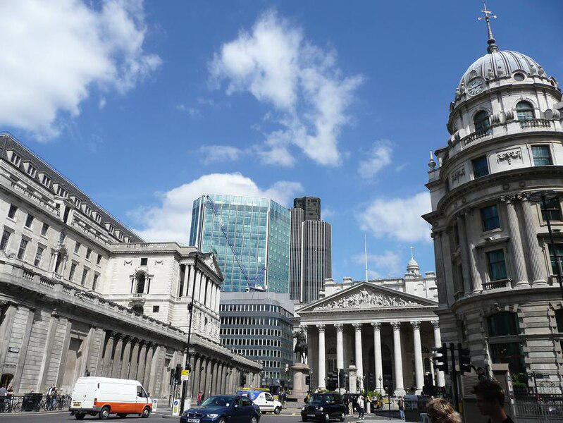

Generated Question - How does Libor relate to the City of London and the banks operating there?

Generated Answer - Libor measures borrowing costs for large banks operating in the City of London financial markets.

--- Entry for custom_id: d5dfa6d40dba11ecb1e81171463288e9 ---

Example Question - The method of modeling what, which in biology is the similarity due to shared ancestry between a pair of structures or genes in different taxa, is based on the observation that protein tertiary structure is better conserved than amino acid sequence?

Example Answer - homology

Image Source 1 -

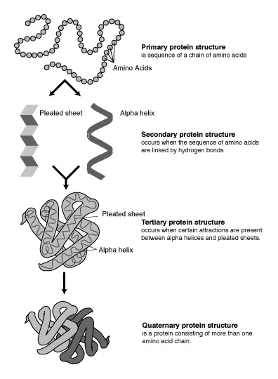

Generated Question - Which protein structure level is better conserved than amino acid sequence and used in homology modeling based on shared ancestry?

Generated Answer - Tertiary protein structure

--- Entry for custom_id: d5d13d100dba11ecb1e81171463288e9 ---

Example Question - Which operated in a wider market: American Association of Professional Baseball or United League Baseball?

Example Answer - American Association of Professional Baseball operated in a wider market.

Image Source 1 -



Generated Question - Which league had a longer continuous operation period, United League Baseball or the American Association of Professional Baseball?

Generated Answer - The American Association of Professional Baseball had a longer continuous operation period.

--- Entry for custom_id: d5c7276c0dba11ecb1e81171463288e9 ---

Image Source 1 -

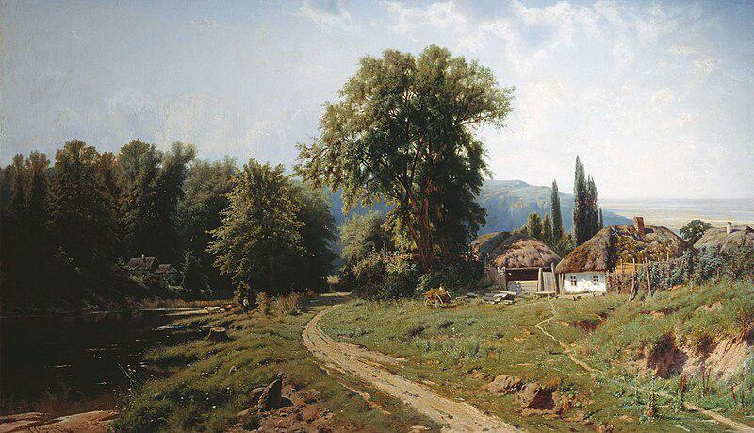

Caption for image source 1: KonstantinKryzhitsky HutorVMalorossii 1884 Khutir (or hamlet) in Little Russia, 1884.

Example Question - "What material is the roof of the house in Constantin Kryjitski's "Khutir (or hamlet) in Little Russia, 1884" made from?"

Example Answer - "The roof of the house is thatched in Constantin Kryjitski's "Khutir (or hamlet) in Little Russia, 1884."

Additional Text Source 1 - In his prominent work Two Russian nationalities, Kostomarov uses Southern Russia and Little Russia interchangeably. Mykhailo Drahomanov titled his first fundamental historic work Little Russia in its literature (1867–1870). (from: Little Russia)

Generated Question - Does the painting "Khutir (or hamlet) in Little Russia, 1884" depict a rural area consistent with the historical use of the term Little Russia for Southern Russia?

Generated Answer - Yes, the painting shows a rural hamlet consistent with Little Russia referring to Southern Russia.

--- Entry for custom_id: d5d17d980dba11ecb1e81171463288e9 ---

Example Question - Does the auriculotemporal nerve run parallel to the superficial iliac circumflex artery?

Example Answer - No, the superficial iliac circumflex artery is in the leg and the auriculotemporal nerve is in the head.

Image Source 1 -

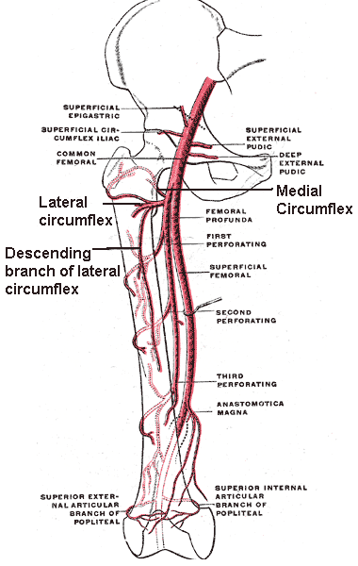

Generated Question - Are the superficial circumflex iliac artery and the circumflex femoral arteries branches of the same main artery in the thigh?

Generated Answer - No, the superficial circumflex iliac artery branches from the femoral artery, while the circumflex femoral arteries branch from the profunda femoris artery.

--- Entry for custom_id: d5d0c7220dba11ecb1e81171463288e9 ---

Example Question - What is the basic difference between the reflectivity on individual PPI angles and composite reflectivity?

Example Answer - The reflectivity on individual PPI angles show the precipitation intensity at that specific angle above the horizon while the composite reflectivity is the maximum dBZ reflectivity from any of the reflectivity angles of the NEXRAD weather radar

Image Source 1 -

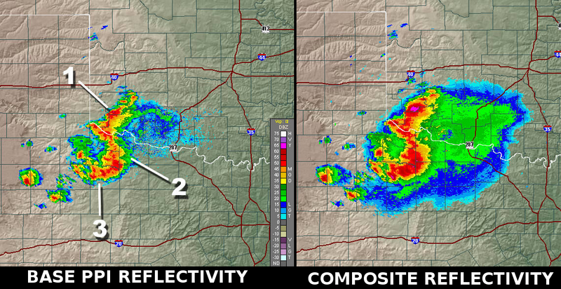

Generated Question - Why does the composite reflectivity image show the fuchsia region that is missing in the base PPI reflectivity image?

Generated Answer - Because composite reflectivity shows the maximum reflectivity from all angles, capturing higher intensity regions missed at a single PPI angle.

--- Entry for custom_id: d5c95f6e0dba11ecb1e81171463288e9 ---

Image Source 1 -

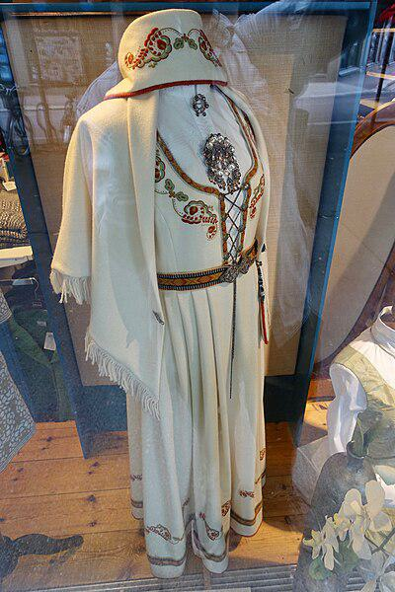

Caption for image source 1: Vestfoldbunad Den broderte Segerbrandt-bunaden For sale at Vestfold-Stua in Tønsberg, Norway (reconstructed traditional folk costume of Vestfold county with embroidery) 2019-08-27 5281 Brodert vestfoldbunad / Segerbrandt-bunaden; Norwegian bunad (reconstructed traditional/folk costume) of Vestfold County, model with embroidery designed by Petrine Segerbrandt (born 1880), for sale at Vestfold-Stua women's clothing store in Tnsberg, Norway..

Image Source 2 -



Caption for image source 2: Amerindian woman in her traditional clothes.png photo of an amerindian woman in her traditional clothes.

Example Question - "Can floral designs be found in both the traditional folk costume of Vestfold county, Norway and traditional Amerindian women clothing?"

Example Answer - "Yes, floral designs can be found in both the traditional folk costume of Vestfold county, Norway and traditional Amerindian women clothing."

Additional Text Source 1 - Other commentators link the upsurge in folk costume to economic insecurity caused by globalization, prompting a return to traditional cultural symbols. Simone Egger concludes that the renewed popularity of traditional clothing is driven by desires for community and belonging, symbolized by folk costume. (from: Dirndl)

Generated Question - How might the floral embroidery on the Vestfoldbunad and the Amerindian traditional clothing reflect a shared cultural response to globalization?

Generated Answer - Both use floral designs to symbolize community and cultural identity amid globalization.

--- Entry for custom_id: d5cc2ab40dba11ecb1e81171463288e9 ---

Image Source 1 -



Caption for image source 1: BMLRR City Point Trestle (MP 2.0) BML#50 and BML#53, a pair of late 1940's GE 70-ton diesel electric locomotives, crossing the BML's City Point Trestle (MP 2.0) at the "Head of Tide" heading inland from Belfast, Maine, on the 33-mile Belfast and Moosehead Lake Railroad main line to Burnham Junction..

Example Question - "What runs under the train tracks on the BML's City Point Trestle?"

Example Answer - "Water runs under the train tracks on the BML's City Point Trestle."

Additional Text Source 1 - The City point Railroad began to operate on September 7, 1938. The railroad started at City Point, where the Appomattox River runs into the James River because the Appomattox River was not as deep and wide as would allow large ships to dock closer to Petersburg. (from: City Point Railroad)

Generated Question - Does the City Point Trestle in the image cross over a river similar to where the City Point Railroad started near the Appomattox River?

Generated Answer - Yes, both the City Point Trestle and the City Point Railroad start near rivers.

--- Entry for custom_id: d5c2c5640dba11ecb1e81171463288e9 ---

Image Source 1 -

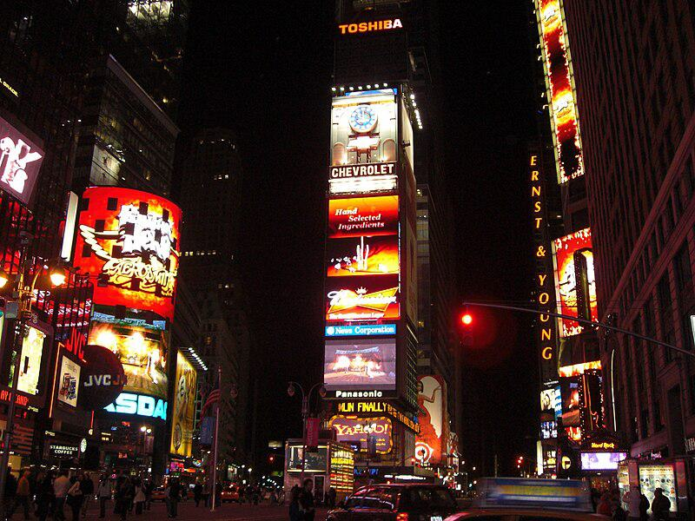

Caption for image source 1: Times Square, New York, USA1 Times Square, New York, USA.

Example Question - "Does Times Square feature ads from Chevrolet?"

Example Answer - "Chevrolet ads are featured in Times Square."

Additional Text Source 1 - Following its sale to Lehman Brothers in 1995, One Times Square was re-purposed with advertising billboards on its facade to take advantage of its prime location within the square. (from: One Times Square)

Generated Question - Is the prominent building in Times Square used mainly for advertising after its sale to Lehman Brothers?

Generated Answer - Yes, One Times Square is mainly used for advertising billboards after the sale.

--- Entry for custom_id: d5de28a40dba11ecb1e81171463288e9 ---

Example Question - For the individual who discovered the law of gravitation, what did his writings suggest towards the main goals of alchemy?

Example Answer - Discovery of the philosopher's stone and Elixir of Life.

Image Source 1 -

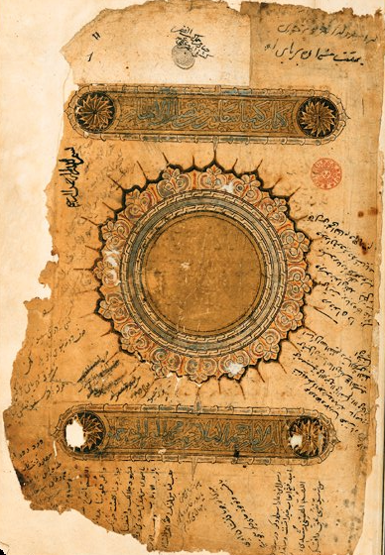

Generated Question - How do Newton's alchemical goals compare to the themes in Al-Ghazālī's 11th-century alchemy text shown in the image?

Generated Answer - Both focus on transformative and mystical aspects of alchemy, like philosopher's stone and spiritual happiness.

--- Entry for custom_id: d5df9e3c0dba11ecb1e81171463288e9 ---

Example Question - What item of diving equipment called a manned torpedo is used by scuba divers to increase range underwater?

Example Answer - A diver propulsion vehicle.

Image Source 1 -

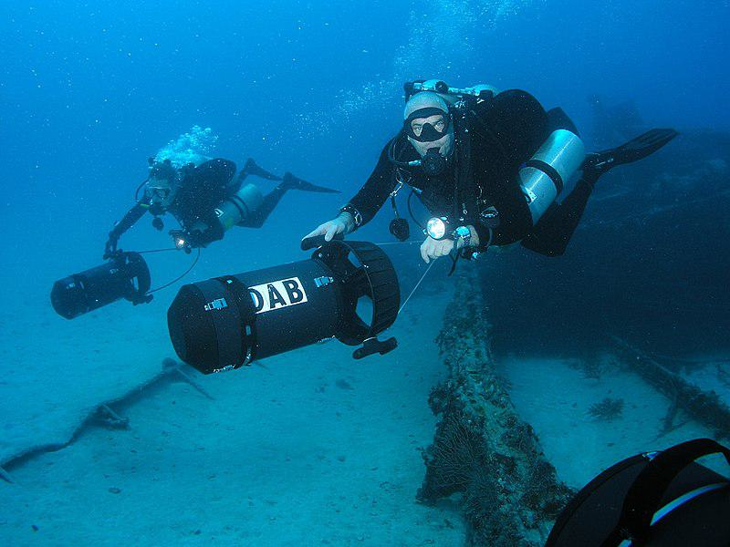

Generated Question - How do modern diver propulsion vehicles used by scuba divers compare to World War II human torpedoes in purpose?

Generated Answer - Both are used to increase underwater range, but human torpedoes were secret naval weapons.

--- Entry for custom_id: d5c789820dba11ecb1e81171463288e9 ---

Image Source 1 -

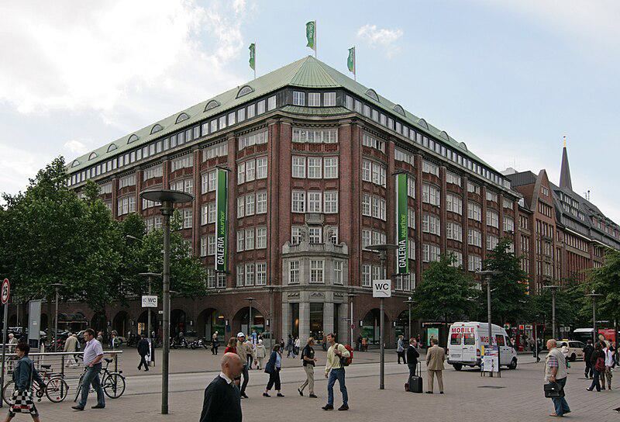

Caption for image source 1: Galeria Kaufhof Hamburg Galeria Kaufhof im Klopperhaus an der Monckebergstrae in Hamburg-Altstadt..

Example Question - "How many flags are atop the Galeria Kaufhof Hamburg?"

Example Answer - "There are three flags atop the Galeria Kaufhof Hamburg."

Additional Text Source 1 - The new building was carried out by the Galeria Kaufhof years later. After the completion of the new building, the Horten store was closed and converted into a shopping center. (from: Horten AG)

Generated Question - Was the Galeria Kaufhof Hamburg built before or after the Horten store was converted into a shopping center?

Generated Answer - The Galeria Kaufhof Hamburg was built after the Horten store was converted into a shopping center.

--- Entry for custom_id: d5d9d22c0dba11ecb1e81171463288e9 ---

Example Question - What were the Messerschmitt Bf 109 and 152 air aces from Canada involved in?

Example Answer - World War II.

Image Source 1 -

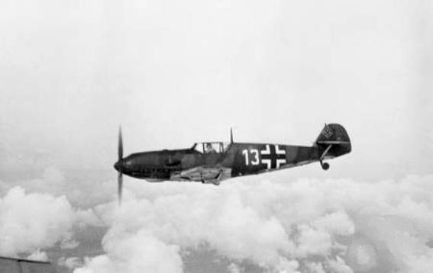

Generated Question - Did the German Luftwaffe fighter aces in World War II primarily fly the Bf 109 shown in the image?

Generated Answer - Yes, the Bf 109 was a backbone fighter flown by German aces in World War II.

--- Entry for custom_id: d5cb1c8c0dba11ecb1e81171463288e9 ---

Image Source 1 -



Caption for image source 1: 2011-06-15 Mycena sanguinolenta (Alb. & Schwein.) P. Kumm 151560.

Example Question - "Do the caps on the Mycena sanguinolenta have bumps?"

Example Answer - "The caps on the Mycena sanguinolenta have bumps."

Additional Text Source 1 - Mycena californiensis may be distinguished from the closely related M. atromarginata by its smaller size and the purplish tint to the edge of the gills, and from M. purpureofusca by its differently shaped, longer spores. Another Mycena commonly confused with M. californiensis is M. sanguinolenta, a species that also exudes reddish latex. (from: Mycena californiensis)

Generated Question - Can Mycena sanguinolenta be confused with Mycena californiensis due to similar reddish latex secretion?

Generated Answer - Yes, both species exude reddish latex and can be confused.

--- Entry for custom_id: d5c72fb40dba11ecb1e81171463288e9 ---

Image Source 1 -

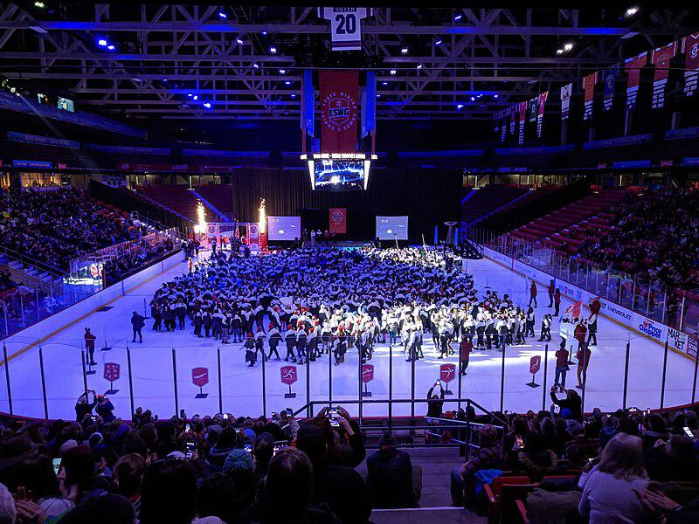

Caption for image source 1: EmpireStateWinterGames2020OpeningCeremony Opening ceremony for the 2020 Empire State Winter Games in the Olympic Center.

Example Question - "How many big screens surround the stage on the ice rink at the 2020 Empire State Winter Games opening ceremony?"

Example Answer - "There were three big screens surrounding the stage on the ice rink at the 2020 Empire State Winter Games opening ceremony."

Additional Text Source 1 - Fluctuating weather conditions challenged the hosts. The opening ceremony was held in a blizzard while warm weather conditions plagued sporting events throughout the rest of the games. (from: Winter Olympic Games)

Generated Question - How did the weather conditions during the 2020 Empire State Winter Games affect the opening ceremony and the sporting events?

Generated Answer - The opening ceremony was held in a blizzard, while warm weather affected the sporting events.

--- Entry for custom_id: d5d62f3c0dba11ecb1e81171463288e9 ---

Example Question - The sticky emu bush was first formally described in what year?

Example Answer - Eremophila glutinosa was first formally described by Robert Chinnock in 1979.

Image Source 1 -

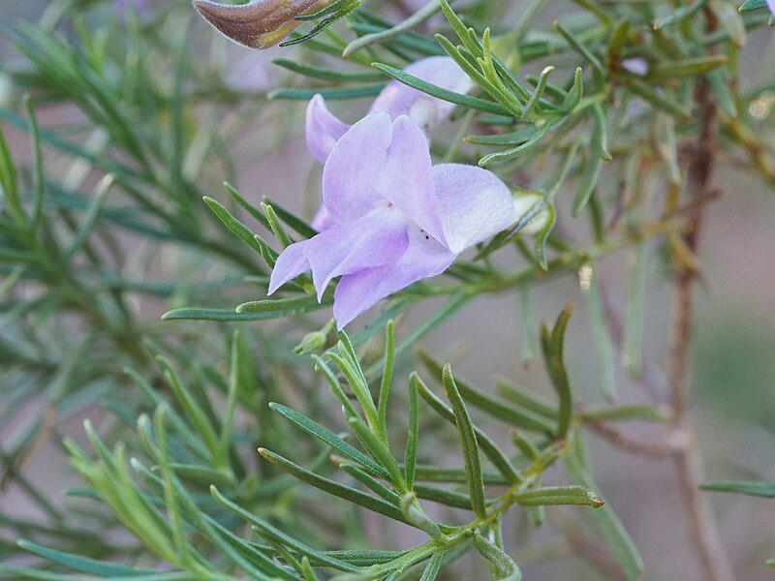

Generated Question - What characteristic of the sticky emu bush's leaves is reflected in its Latin name and visible in the image?

Generated Answer - The leaves are sticky and shiny, which is reflected in the Latin name "glutinosa."

--- Entry for custom_id: d5d1eb660dba11ecb1e81171463288e9 ---

Example Question - Was the NASCAR Winston Cup Series or the NASCAR Busch Series longer in 1992?

Example Answer - The Winston Cup was longer than the Busch Series.

Image Source 1 -



Generated Question - Did the 1992 NASCAR Winston Cup Series or the NASCAR Busch Series start earlier in the year?

Generated Answer - The Winston Cup Series started earlier on February 9, 1992.

--- Entry for custom_id: d5cc4d500dba11ecb1e81171463288e9 ---

Image Source 1 -

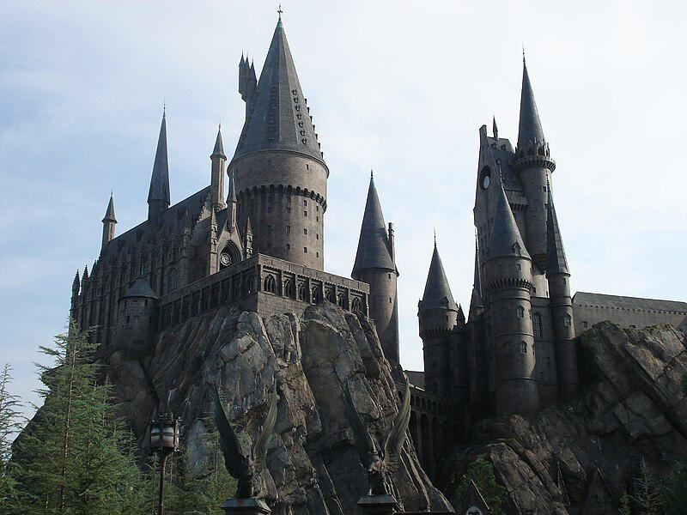

Caption for image source 1: Hogwarts's replica in Universal Studio, Orlando Hogwarts's replica in Universal Studio, Orlando.

Example Question - "What shape is the base of the tallest tower in Hogwarts's replica castle at Universal Studio?"

Example Answer - "It is a circle."

Additional Text Source 1 - Universal's core audience base was still found in the neighborhood movie theaters, and the studio continued to please the public with low- to medium-budget films. (from: Universal Pictures)

Generated Question - Does the Hogwarts replica at Universal Studio, Orlando, reflect the studio's focus on creating visually impressive attractions for its audience?

Generated Answer - Yes, the detailed Hogwarts replica shows Universal's effort to attract and please its audience visually.

--- Entry for custom_id: d5db09da0dba11ecb1e81171463288e9 ---

Example Question - Eel and South Fork American are both names of what?

Example Answer - Rivers

Image Source 1 -

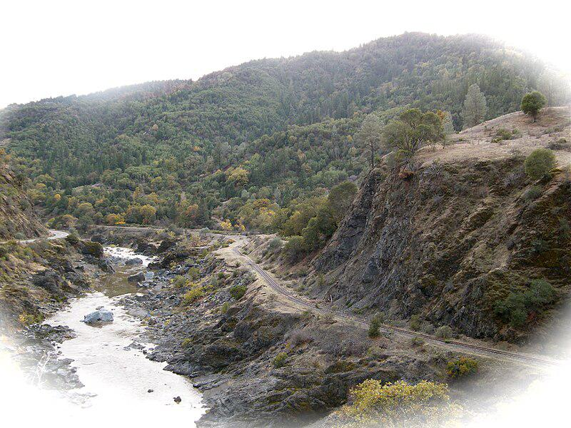

Generated Question - Are the South Fork Eel River and Middle Fork Eel River part of the same river system?

Generated Answer - Yes, both are forks of the Eel River system.

--- Entry for custom_id: d5c9dd7c0dba11ecb1e81171463288e9 ---

Image Source 1 -

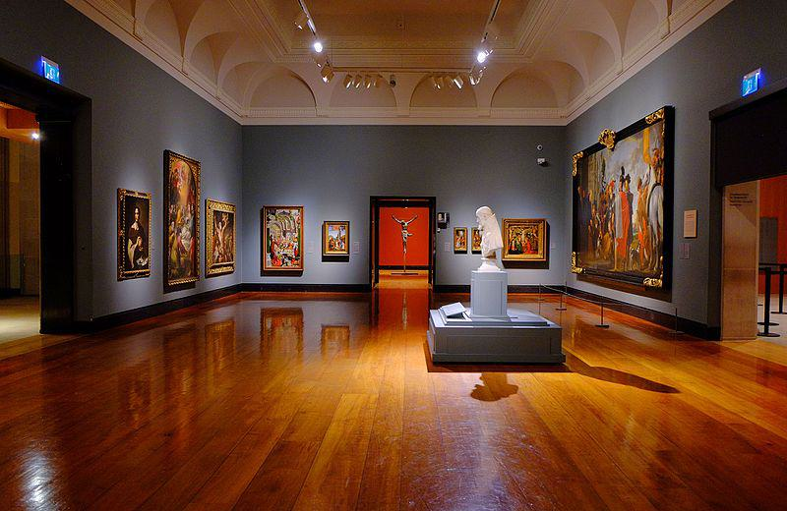

Caption for image source 1: Art Gallery of Ontario (23782351913).

Example Question - "What kind of lighting can be found in the Ontario Art Gallery?"

Example Answer - "Ceiling track lighting can be found in the Ontario Art Gallery."

Additional Text Source 1 - The Art Gallery of Windsor, as it was now known, opened its doors in 1975 and there developed over the span of twenty years one of Ontario's most significant collections of Canadian art. (from: Art Gallery of Windsor)

Generated Question - Are the Art Gallery of Ontario and the Art Gallery of Windsor both known for showcasing Canadian art collections?

Generated Answer - Only the Art Gallery of Windsor is noted for its significant Canadian art collection.

--- Entry for custom_id: d5cf130a0dba11ecb1e81171463288e9 ---

Image Source 1 -



Caption for image source 1: University Club, Virginia Tech The University Club at Virginia Tech in Blacksburg, Virginia.

Example Question - "What color are the awnings over the entryway into the University Club at Virginia Tech?"

Example Answer - "The awnings over the entryway into the University Club at Virginia Tech are green."

Additional Text Source 1 - There are also numerous other academic and service related sororities and fraternities at the school. There are also a number of fraternities at Virginia Tech that are not officially recognized by the university. (from: Virginia Tech)

Generated Question - Does the University Club at Virginia Tech have any green structures similar to the green awnings mentioned, and how does this relate to the presence of fraternities on campus?

Generated Answer - Yes, the University Club has green awnings, and Virginia Tech hosts many fraternities, some unofficial.

--- Entry for custom_id: d5c1bd900dba11ecb1e81171463288e9 ---

Image Source 1 -

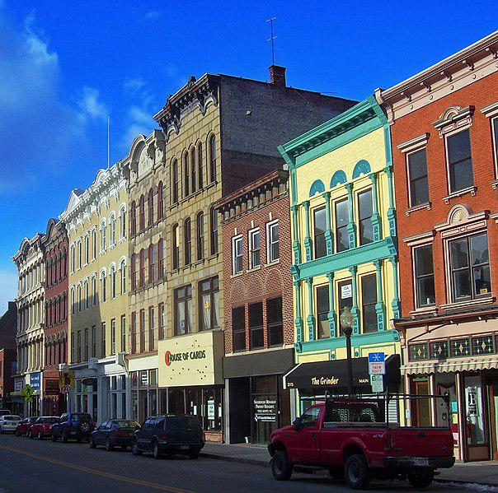

Caption for image source 1: Main Mall Row, Poughkeepsie, NY.

Image Source 2 -

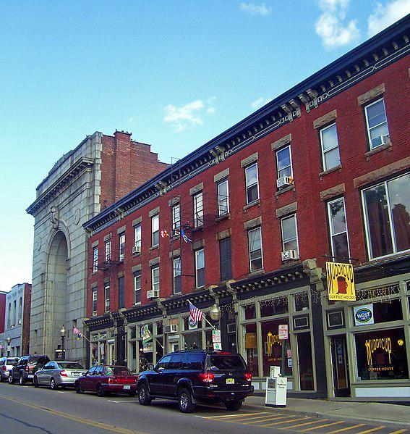

Caption for image source 2: Lower Main Street, Beacon, NY.

Example Question - "Does the Main Mall Row in Poughkeepsie, NY or the Lower Main Street building complex in Beacon, NY have a more colorful facade?"

Example Answer - "The Main Mall Row in Poughkeepsie, NY has a more colorful facade."

Additional Text Source 1 - The building at 3-9 Garden Street retains its original storefronts. The row, as with many of the other buildings in downtown Poughkeepsie, was added to the National Register of Historic Places in 1982. (from: Main Mall Row)

Generated Question - Are the buildings in Main Mall Row in Poughkeepsie, NY more colorful and historically preserved compared to those on Lower Main Street in Beacon, NY?

Generated Answer - Yes, Main Mall Row is more colorful and has original storefronts preserved.

--- Entry for custom_id: d5ca4bf40dba11ecb1e81171463288e9 ---

Image Source 1 -

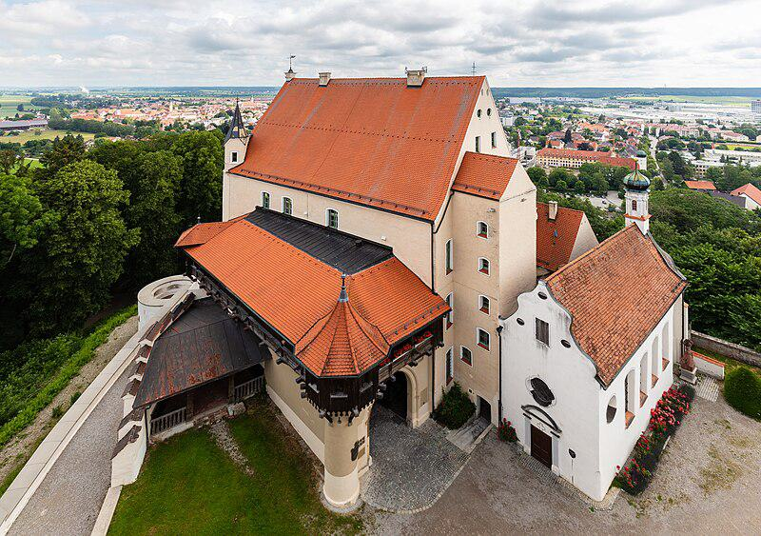

Caption for image source 1: Castillo Mindelburg, Mindelheim, Alemania, 2019-06-21, DD 31 Mindelburg Castle, Mindelheim, Germany.

Image Source 2 -

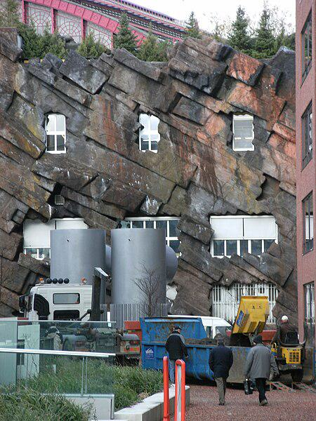

Caption for image source 2: Strange building with fake rock formations Antwerpen Strange building with fake rock formations Antwerpen..

Example Question - "What grows near both a Strange building with fake rock formations in Antwerpen and Mindelburg Castle?"

Example Answer - "Grass grows near both a Strange building with fake rock formations in Antwerpen and Mindelburg Castle."

Additional Text Source 1 - Fake rock formations were built around the second loop and around the first half of the lift hill, with a third formation just before the corkscrews. (from: Demon (roller coaster))

Generated Question - Do both Mindelburg Castle and the strange building in Antwerpen have natural or artificial rock-like structures nearby?

Generated Answer - Mindelburg Castle has natural surroundings, while the Antwerpen building has artificial rock formations.

--- Entry for custom_id: d5bfd9760dba11ecb1e81171463288e9 ---

Image Source 1 -

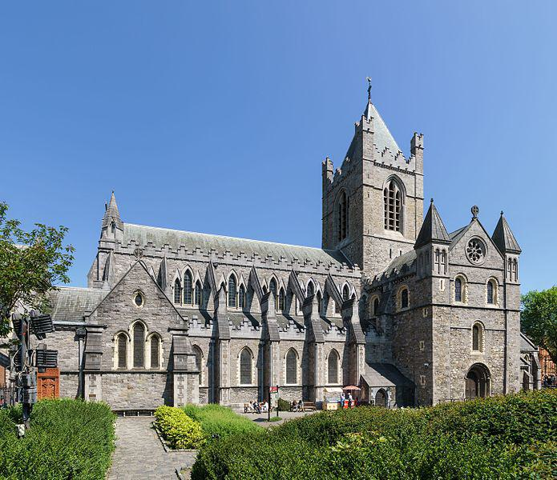

Caption for image source 1: Christ Church Cathedral, Dublin, 2016-06-03 Christ Church Cathedral.

Image Source 2 -

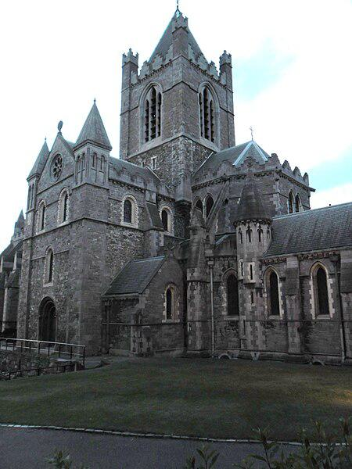

Caption for image source 2: Christ Church Cathedral, Dublin - panoramio.

Example Question - "Does Christ Church Cathedral, Dublin have taller greenery in front or on the sides?"

Example Answer - "The Christ Church Cathedral, Dublin has taller greenery on the sides than in front."

Additional Text Source 1 - For most of their common history, both Christ Church and St Patrick's held the status of cathedral for the Dublin diocese, a rare arrangement which only ended following the move to disestablish the Church of Ireland. (from: Christ Church Cathedral, Dublin)

Generated Question - Considering the historical status of Christ Church Cathedral, Dublin, does its architecture show more prominence in the front or the side views?

Generated Answer - The architecture shows more prominence in the front view with its detailed towers and entrance.

--- Entry for custom_id: d5ce91f00dba11ecb1e81171463288e9 ---

Image Source 1 -

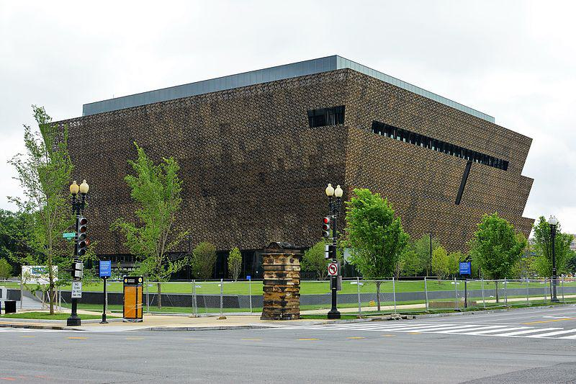

Caption for image source 1: National Museum of African American History and Culture.

Image Source 2 -

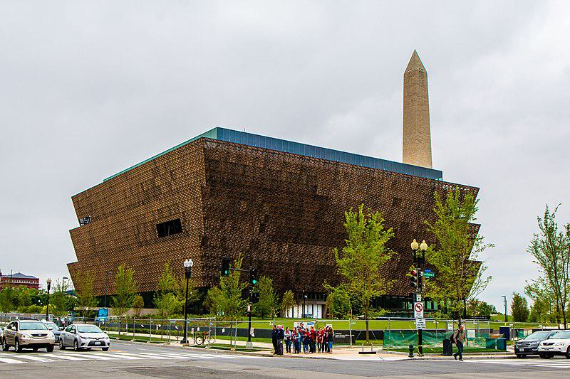

Caption for image source 2: African American Museum Washington, DC The African-American History Museum in Washington, DC.

Example Question - "Are there trees surrounding the African-American History Museum in Washington, DC?"

Example Answer - "Yes, there are trees surrounding the African-American History Museum in Washington, DC."

Additional Text Source 1 - The National Museum of African American History and Culture (NMAAHC) is a Smithsonian Institution museum located on the National Mall in Washington, D.C., in the United States. (from: National Museum of African American History and Culture)

Generated Question - Is the National Museum of African American History and Culture located near the Washington Monument and surrounded by trees?

Generated Answer - Yes, it is near the Washington Monument and surrounded by trees.

--- Entry for custom_id: d5d2efd40dba11ecb1e81171463288e9 ---

Example Question - Which person, who purportedly created abthainries for his brother King Edgar, was called the abbot of Dunkeld?

Example Answer - Ethelred

Image Source 1 -

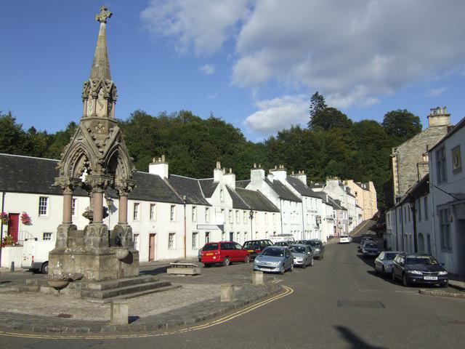

Generated Question - Was the abbot of Dunkeld, possibly a layman like Ethelred, associated with the place shown in the image of Dunkeld Market Place?

Generated Answer - Yes, the abbot of Dunkeld was associated with Dunkeld shown in the image.

--- Entry for custom_id: d5cc33560dba11ecb1e81171463288e9 ---

Image Source 1 -

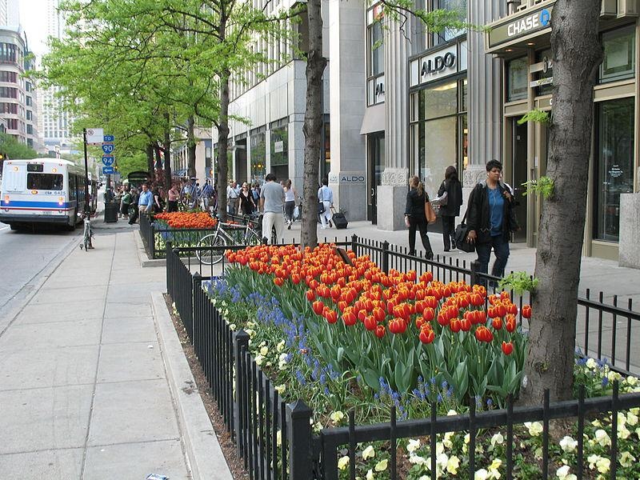

Caption for image source 1: 20070509 Tulip Days 2007 Tulip Days on The Magnificent Mile with CTA bus in view..

Image Source 2 -

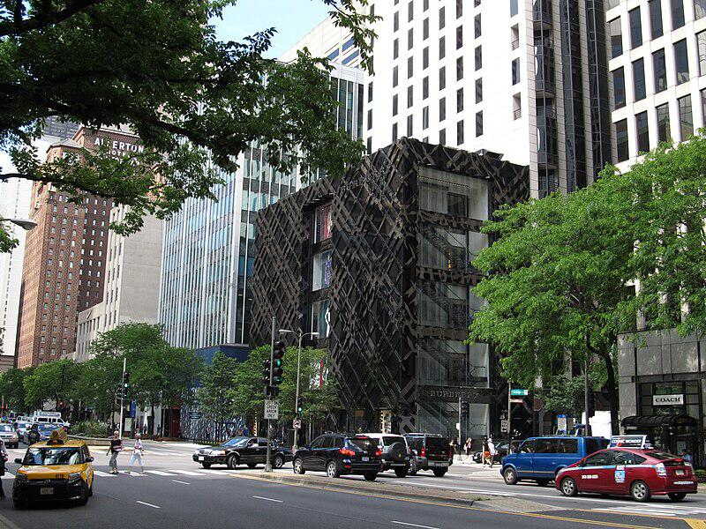

Caption for image source 2: The Magnificent Mile, Michigan Avenue, Chicago, Illinois (9181676490) The Magnificent Mile, sometimes referred to as The Mag Mile, is a prestigious section of Chicago's Michigan Avenue, running from the Chicago River to Oak Street in the Near North Side..

Example Question - "On The Magnificent Mile, what types of transportation service vehicles can be seen?"

Example Answer - "Taxis and buses can be seen on The Magnificent Mile."

Additional Text Source 1 - In 2008, a public art installation of kinetic sculptures designed by local and international architects was placed in the garden beds. During the summer, the "Gardens of The Magnificent Mile" festival event occurs. (from: Magnificent Mile)

Generated Question - How do the gardens and public art installations on The Magnificent Mile enhance the pedestrian experience during events like Tulip Days and Gardens of The Magnificent Mile?

Generated Answer - The gardens with flowers and kinetic sculptures create a vibrant, attractive environment for pedestrians during these events.

--- Entry for custom_id: d5c283060dba11ecb1e81171463288e9 ---

Image Source 1 -



Caption for image source 1: Jeison Angulo USA-Columbia, FIFA U20 World Cup (18679461162) (cropped).

Image Source 2 -



Caption for image source 2: Philipp Lahm, Germany national football team (06) Philipp Lahm (FC Bayern Munich), german national football team This photograph was taken by user Steindy and released under the license(s) stated below..

Example Question - "Do both FC Bayern Munich and Colombia's national football team wear adidas jerseys?"

Example Answer - "Both the FC Bayern Munich and Colombia's national football team wear Adidas jerseys."

Additional Text Source 1 - The Colombia national football team was composed mostly by all the players of the Club Juventud Bogotana (now Millonarios FC). Alfonso Novoa was the manager of Colombia until 23 February. (from: History of the Colombia national football team)

Generated Question - Do both the Colombia national football team and Germany national football team wear Adidas jerseys during their matches?

Generated Answer - Yes, both the Colombia and Germany national football teams wear Adidas jerseys.

--- Entry for custom_id: d5c9722e0dba11ecb1e81171463288e9 ---

Image Source 1 -

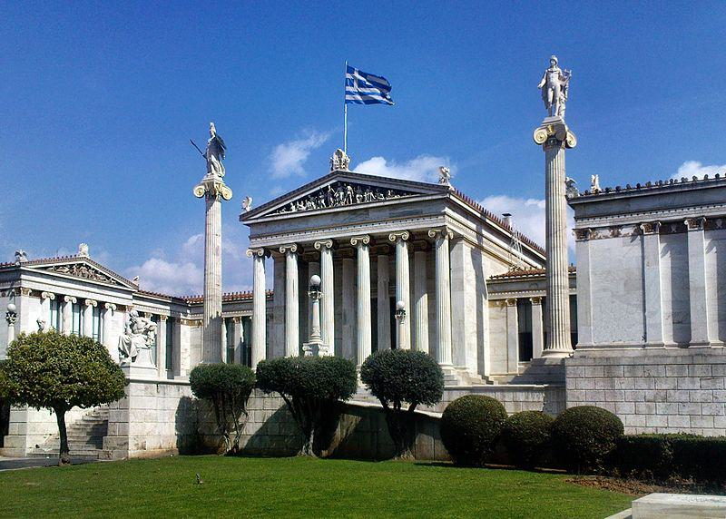

Caption for image source 1: Athens academy Academy of Athens.

Example Question - "At the Academy of Athens how many columns have a statue depicting a human on top of them?"

Example Answer - "Two columns have a statue depicting a human on top of them at the Academy of Athens."

Additional Text Source 1 - Later in the mid and late 19th century, Theophil Freiherr von Hansen and Ernst Ziller took part in the construction of many neoclassical buildings such as the Athens Academy and the Zappeion Hall. (from: Athens)

Generated Question - Are the statues on top of the columns at the Academy of Athens likely influenced by the neoclassical style of architects like Theophil Hansen and Ernst Ziller?

Generated Answer - Yes, the statues reflect the neoclassical style promoted by Hansen and Ziller.

--- Entry for custom_id: d5dbab1a0dba11ecb1e81171463288e9 ---

Example Question - How many years after the death of Ptolemy IV was Arsinoë's defeat by Julius Caesar?

Example Answer - 156 years

Image Source 1 -

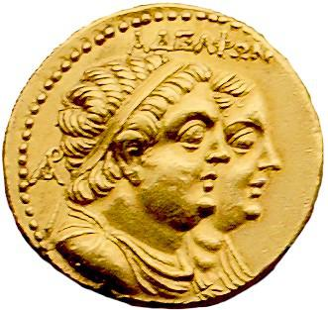

Generated Question - How many years after the reign of Ptolemy II Philadelphus did Arsinoë IV live and rebel against Julius Caesar?

Generated Answer - Arsinoë IV lived about 200 years after Ptolemy II Philadelphus.

--- Entry for custom_id: d5ce857a0dba11ecb1e81171463288e9 ---

Image Source 1 -

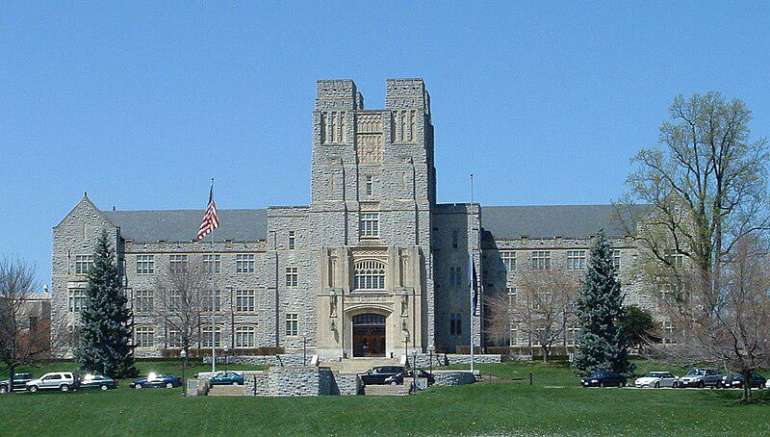

Caption for image source 1: Virginiatech-burrusshall-fromdrillfield Virginia Tech's Burruss Hall taken from the drillfield.

Example Question - "Is Virginia Tech's Burruss Hall symmetrical or asymmetrical?"

Example Answer - "Virginia Tech's Burruss Hall is symmetrical."

Additional Text Source 1 - Constructed in 1936 facing the center of the drill field and originally known as the Teaching and Administration Building, Burruss Hall is the main administration building on campus and the iconic symbol of Virginia Tech. A west wing and rear addition were built in 1968, and an east wing was added in 1970. (from: Campus of Virginia Tech)

Generated Question - Considering the additions made in 1968 and 1970, does Burruss Hall maintain its symmetrical appearance from the front view?

Generated Answer - Yes, Burruss Hall maintains a symmetrical appearance despite the additions.

--- Entry for custom_id: d5c987960dba11ecb1e81171463288e9 ---

Image Source 1 -



Caption for image source 1: Eighth Avenue Place - East Tower, 2010-09-29.

Image Source 2 -

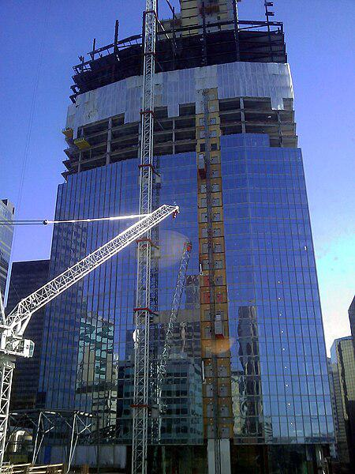

Caption for image source 2: Penny Lane Towers construction Construction of 8th Avenue place (Penny Lane Towers) in April 2010. Calgary, Alberta, Canada.

Example Question - "From which direction were the glass windows installed on the Penny Lane Towers?"

Example Answer - "The glass windows on the Penny Lane Towers were installed from the bottom up."

Additional Text Source 1 - Prior to construction, concerns had been raised over the destruction of the 94-year-old Penny Lane Mall; however, the City of Calgary approved the project in March 2006. (from: Eighth Avenue Place)

Generated Question - How does the construction progress of the glass windows on Eighth Avenue Place compare to the concerns raised about Penny Lane Mall's destruction?

Generated Answer - The glass windows on Eighth Avenue Place were installed progressively from the bottom up despite concerns over Penny Lane Mall's destruction.

--- Entry for custom_id: d5d8173e0dba11ecb1e81171463288e9 ---

Example Question - Of Gaius Julius Caesar and Trajan, which would have existed further after the death of Jesus?

Example Answer - Trajan would have existed further after.

Image Source 1 -

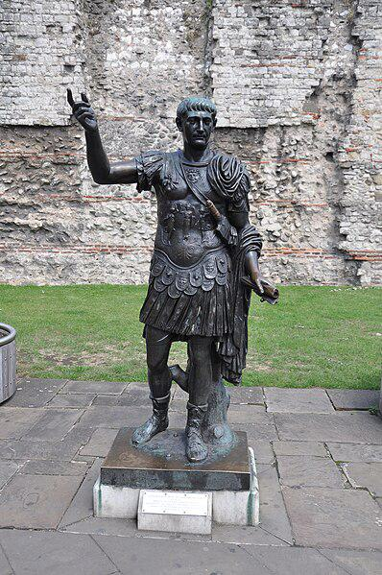

Generated Question - Considering the founding of Traianoupolis and the granting of Roman citizenship, which emperor's actions occurred later in history, Trajan or Julius Caesar?

Generated Answer - Trajan's actions occurred later in history than Julius Caesar's.

--- Entry for custom_id: d5d2aa380dba11ecb1e81171463288e9 ---

Example Question - In the history of Lincolnshire and Lancashire counties, which county was recorded in the Domesday Book?

Example Answer - Lincolnshire was recorded in the Domesday Book as Lindsey, while Lancashire did not exist as a county in the Domesday Book.

Image Source 1 -

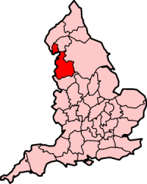

Generated Question - Which county, Lincolnshire or Lancashire, was historically divided into parts and which was formed later with two separate areas?

Generated Answer - Lincolnshire was divided into parts including Lindsey, while Lancashire was formed later with two separate areas.

--- Entry for custom_id: d5d5ff6c0dba11ecb1e81171463288e9 ---

Example Question - Darling River and Goulburn River are both located where?

Example Answer - New South Wales, Australia

Image Source 1 -

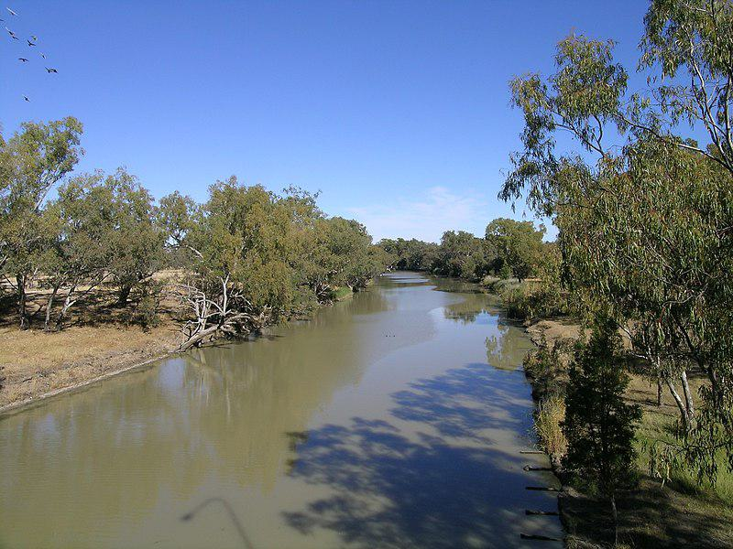

Generated Question - Do the rivers shown in the image and the Goulburn River both flow within New South Wales but belong to different catchments?

Generated Answer - Yes, the Barwon River flows west and the Goulburn River is part of the Hunter catchment in New South Wales.